Electrophilic Reactions in Toxicology

Organic Chemistry Concept: Electrophilic Chemical Reactions (S_{N}1, S_{N}2, Acylation, Schiff Base Formation, Michael Addition)

Organic Chemistry Concept Map: 5.B.1; 5.D.1-2.

Toxicology Concept: The role of electrophilicity and nucleophilicity in toxicological mechanisms

Literature Article/Reference: Measurement and Estimation of Electrophilic Reactivity for Predictive Toxicity, Cronin, M.T.D., et. al., Chem. Reviews, 2011, 111, 2562-2596.

Introduction:
Electrophilic-Nucleophilic reactions are one of the most common reactions in biological systems that can initiate a toxicological effect. The electrophilic-nucleophilic reactions result in the covalent binding between an electrophile (a xenobiotic molecule) and an endogenous nucleophile. Not all electrophilic molecules introduced into the body will react with the biological nucleophiles. However, it is useful to understand more about what properties of the electrophiles and nucleophiles make them more likely to react.

Electrophilicity and Nucleophilicity in Toxicological Mechanisms:
Biological nucleophiles: There are many nucleophilic target sites found in biological molecules – such as peptides, proteins or enzymes, lipids, DNA and related biological molecules. These target sites are predominantly “hard” nucleophiles, meaning they are not readily oxidized. As a general rule of thumb (keep in mind there are always exceptions), the principles of like reacts with like applies – hard electrophiles will be more likely to react with hard biological nucleophiles (i.e., DNA and amino groups such as lysine). And, soft electrophiles will be more likely to react with soft nucleophiles found in the body – such as the thiol group of cysteine on proteins.

Xenobiotic electrophiles: Hard electrophiles are small molecules with low polarizability. Soft electrophiles are generally large molecules and are highly polarized. Electrophilic molecules introduced into the body will generally follow the rule of like-reacts-with-like (i.e., soft-with-soft and hard-with-hard). However, many electrophiles are not specific in regards to their molecular targets. Many are able to react with several different biological nucleophilic targets.

Biological nucleophilic sites and their relative hardness:
Hardness (1-4 least to most) | Site | Structure
 | Amino acid sites
1 | Thiol-group of cysteine | 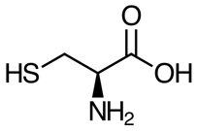
2 | S-atoms of methionine | 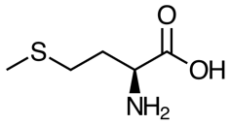
3 | Primary amino-groups (e.g., lysine, arginine) | 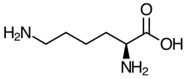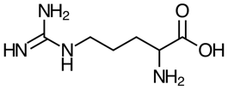
4 | Secondary amino-group of histidine | 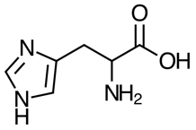
 | Nucleic acid sites
1 | Primary amine groups of purine bases (e.g., arginine, guanine) | 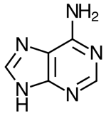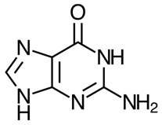
2 | In-ring N-atoms of purine and pyrimidine bases (e.g., N7 of guanine) | 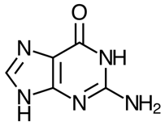
3 | O-atoms of purine and pyrimidine bases (e.g., O6 of guanine) | 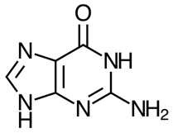
4 | Phosphate O-atom (P=O) | 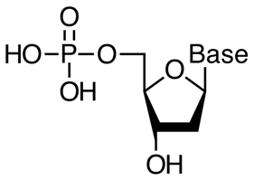

Covalent binding mechanisms in toxicology:
The toxicity of xenobiotic electrophiles are related to their intrinsic capability to bind to proteins. There are about 50 specific reactive protein binding mechanisms that are known. However, 6 are the most common and capture the general mechanisms of protein binding in toxicology.

Mechanism | Protein Binding Reaction
S_{N}2 | 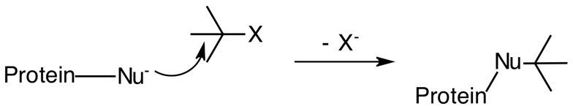
S_{N}1 | 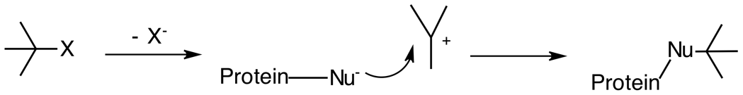
Acylation | 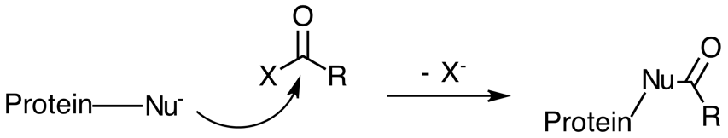
Schiff Base Formation | 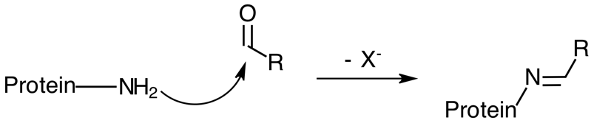
Michael Addition | 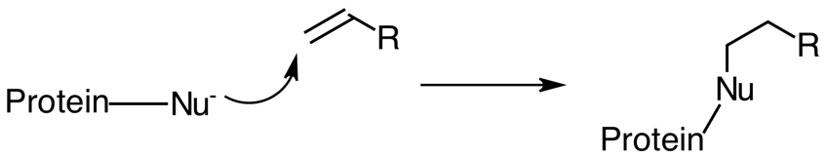
S_{N}Ar | 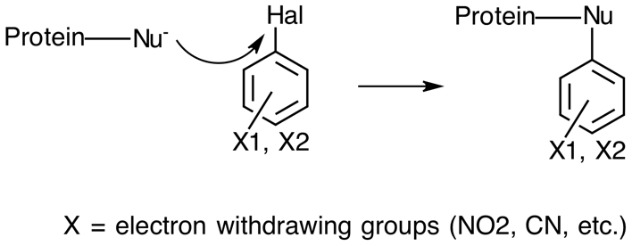

Discussion Questions:

- Given the following xenobiotic molecules (electrophiles), propose which of the 6 reaction mechanisms this electrophile will undergo with a biological nucleophile.
  - Acrolein
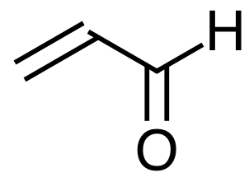

  - Methyl iodide
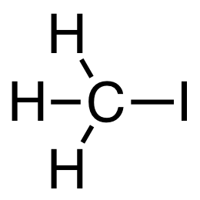

  - Benzoyl chloride
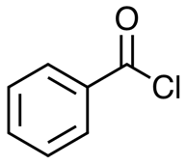

  - 4-nitrochlorobenzene

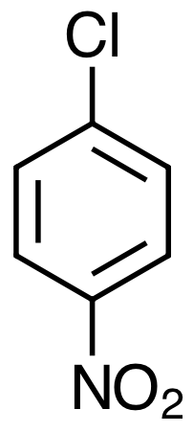

Some examples of electrophilic reactions in toxicity:
Toxicity | Reaction site | Main reaction mechanism
Skin sensitization | Chemically modified skin proteins (e.g., Cys, Lys, or Ser residues) leading to T-cell mediated allergic response | Protein haptenation via S_{N}2, S_{N}Ar, MA, SB, Ac
Respiratory sensitization | Chemically modified proteins in the lung (e.g., Lys residues) | SB, protein cross-linking, S_{N}1, S_{N}2, Ac
Skin irritation | Skin proteins and lipids in the stratum corneum | SB, S_{N}2, MA, Ac, A_{N}
Elevated acute toxicity and cytotoxicity (aquatic or terrestrial) | Cellular GSH; interaction with nucleophiles (-OH, -NH2, -SH groups) in biological macromolecules (e.g., inhibition of acetylcholine esterase) | Electrophilic reactivity via S_{N}1, S_{N}2, acylation, MA, SB (in contrast to polar and unpolar narcosis)
Mutagenicity and carcinogenicity | DNA or RNA gene mutation via adduct formation, base pair substitutions, and frameshifts; interaction with regulatory molecules | SN1, SN2, acylation, MA, SB
Chromosomal aberration | Alteration of DNA and sequence of genetic material (number of structure of chromosomes), which often alters embryonic development; inhibition of topoisomerases and interaction with nuclear proteins associated with DNA (e.g., histone proteins) | DNA and protein binding mechanisms
Hepatotoxicity | Attack of hepatocytes, the bile duct, or sinusoidal endothelium, Kupffer, or Ito cells by: 1) direct cell stress, direct mitochondrial impairment, and specific immune reactions; 2) direct and death receptor-mediated pathways leading to mitochondrial permeability transition; 3) apoptosis and necrosis | Protein binding and receptor-mediated mechanisms (e.g., interaction with P-450 enzyme family, leading to damaged mitochondrial functions and possible idiosyncratic effects)

MA = Michael Addition; SB = Schiff Base Formation; Ac = Acylation; A_{N} = Nucleophilic addition

