**Homework 2 -Stoichiometry and Reactions**

**Description:**

In this assignment, you will have the opportunity to apply your nomenclature knowledge, practice stoichiometry calculations, balance reactions, and determine atom economical reactions.

**Questions: Note to instructor: Below is a list of questions that are suitable for a homework assignment. You may select any number of question that you may feel is best suited for your class. This serves a guide and additional questions are welcome.**

1. **In 2014, the largest manufacturer of automotive vehicle airbags, Takata, recalled millions of their airbags. Did you know that the deploying of an air bag is chemistry! The chemical reaction that takes place is as follows:**

**NaN3(s) 🡺 Na(s) + N2(g)**

1. What are the molecular weights of NaN3, Na, & N2?
2. What type of reaction is this?
3. Is the above reaction balanced? Write the correct balance chemical reaction
4. Based upon this reaction, why does the airbag inflate
5. **Balance the following equations:**

H2 + O2 🡪 H2O

H2 + N2 🡪 NH3

Al2O3 🡪 Al + O2

KClO3 🡪 KCl + O2

S8 + O2 🡪 SO2

Al2(SO4)3 + Ca(OH)2 🡪 Al(OH)3 + CaSO4

AgNO3 + K3PO4 🡪 Ag3PO4 + KNO3

1. **The Haber process is an industrial important reaction. It’s known for its ability to manufacture ammonia by reacting hydrogen and nitrogen. Ammonia is a very important starting block for a wide range of fertilizers, pesticides, and pharmaceuticals. The Haber reaction is as follows:**

**H2(g) + N2(g) 🡺 NH3(g)**

1. What type of reaction is the Haber process?
2. Write the correct balanced equation
3. Put on your Green Chemist hat. Can you think of anything associated with the Harber process that might address the need for a Green Chemistry solution? If so, what Green Chemistry principle best fits your answer?
4. **Ozone, O3, undergoes a decomposition reaction and decomposes into oxygen gas. Write out the balanced chemical equation.**
5. **Uranium(IV) oxide undergoes a reaction with hydrogen fluoride to produce Uranium(IV) fluoride and water. Write out the balance equation. How many molecules of water is made? How many molecules of the product is made?**
6. **In 1774, Joseph Priestly made the discovery of oxygen by experimenting with what was called “red calx of mercury”. Upon its heating, it decomposes to its elements. The reaction is:**

**HgO 🡺 Hg + O2**

1. Balance the equation
2. What is the proper nomenclature for “red calx of mercury”
3. What mass of oxygen is created by the decomposition of 18.0g of HgO? Show all work.
4. **The combustion reaction is another type of reactions. A combustion reaction is when a molecule reacts with oxygen to form carbon dioxide and water. Butane is a component of petroleum gas and reacts with oxygen to produce a combustion reaction. Answer the following:**
5. Draw out the structure of butane
6. Butane belongs to what functional group?
7. Write down the chemical reaction.
8. What is the balanced reaction?
9. How many moles of CO2 are produced when 0.845 moles of butane react with oxygen? Show work.
10. How many moles of oxygen are required to burn 2.54 moles of butane?
11. **Calculate the molar mass of the following compounds (in g/mol) and show your work.**



1. **How many moles of methane are found in 6.07 g of methane? Show your work**
2. **Which type of reaction has the highest atom economy (2 pts)?**
3. **This following is the chemical process for the production of TiO2. What is the atom economy of this reaction?**

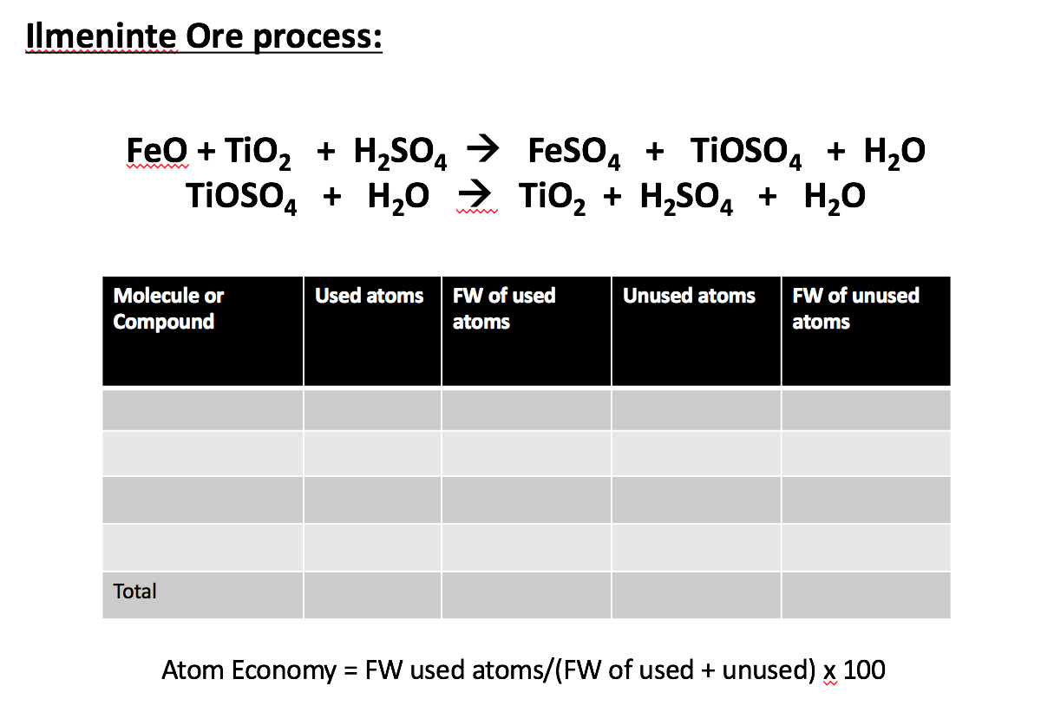

1. **What is the best E-factor possible (2 pts)? Is this tangibly possible?**