Homework 5 – Chemical Exposure and Dose

One of the graphs below represents a dose-response curve. On that one graph (40 points):
- label what is being measured on the x and y axes;
- identify the LOAEL and NOAEL points;
- assuming the response is “death”, mark the LD50 point.

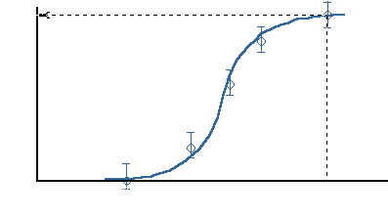

What is total dose (10 points)?

- the amount of substance administered in one sitting
- the number of pills in the package
- the quantity of a substance administered over a period of time or in several individual doses
- one serving

Knowledge of the dose-response relationship permits one to determine (circle all applicable answers) (10 points):
- Whether exposure has caused an effect, threshold for the effect, and the rate of buildup of the effect with increasing dose levels.
- The degree of metabolism of a toxicant.
- Causality between adverse effect and substance.

Plotted here are two theoretical curves for the toxicity of solvents used in the cleaning of silicon compounds. Both solvent 99-2 and 99-7 performed equally well against a variety of manufactured silicon compounds. The task at hand for you is to determine which solvent would you pick to be “safer” for use. As you can see from the accompanying data both compounds have an equivalent Lethal Dose 50 value (LD50). These are based on average values during a 6 hours exposure period (40 points).

What is the estimated LD50 value for both of the solvents?

What solvent would you choose based on the toxicity data available to you? Explain why.

