**Questions: Note to instructor: Below is a list of questions that are suitable for a exam You may select any number of question that you may feel is best suited for your class. This serves a mere guide and any additional questions are welcome.**

**Questions for Final Exam**

1. **What is the Definition of Green Chemistry?**

“Green Chemistry is a revolutionary approach to the way that products are made; it is a science that aims to reduce or eliminate the use and/or generation of hazardous substances in the design phase of materials development”

1. **List 6 of the 12 Principles of Green Chemistry**

1. Waste Prevention

2. Atom Economy

3. Less Hazardous Chemical Synthesis.

4. Designing Safer Chemicals.

5. Safer Solvents and Auxiliaries.

6. Design for Energy Efficiency.

7. Use of Renewable Feedstocks.

8. Reduce Derivatives.

9. Catalysis.

10. Design for Degradation.

11. Real-time Analysis for Pollution Prevention.

12. Inherently Safer Chemistry for Accident Prevention

1. **What are the 3 Pillars of Green Chemistry?**

Economics, Cost, and Performance

1. **What happened in 1984 in Bhopal, India?**

A massive gas leak occurred at a Union Carbide plant where over 500,000 local residents were exposed to toxic methyl isocyanate gas! It’s considered to be one of the worst industrial disaster to date. Approximately 4,000 deaths occurred.

Decades later, residents are still impacted by the effects of the gas leak. Also the health of the residents has been compromised and the long term effects are yet to been reported.

1. **Fill in the blanks:**
2. **Risk = _Hazard__ + _Exposure____**
3. **How does Green Chemistry reduce Risk?**

Green Chemistry reduces risk by actively reducing the hazard through the 12 Principles.

1. **For companies who have won the Presidential Green Chemistry Awards, what were the benefits of implementing the 12 Principles of Green Chemistry?**

Instructor may reference a specific case study that he/she assigns the class to read. Refer to the PDF detailing the presidential Green Chemistry Awards to formulate your rubric.

Acceptable answers are:

* 1. Atom Economy
  2. Reducing Derivatization
  3. Inherent safer products
  4. Accident prevention
  5. And so on…..

1. **For companies that have implemented Green Chemistry into their research, how has Green Chemistry saved money? Applying certain Principles are acceptable.**

* Reduction in waste
* Decreased solvent use
* Less derivatization steps
* More benign solvents (i.e water)
* More energy efficient reactions
* Reduced reaction times = less labor costs

1. **You are an intern at a chemical company. Shortly after starting, you noticed that the research lab wasn’t very concerned with the hazards associated with the products they were making. You noticed that solvent usage wasn’t a concern, chemists were producing a lot of organic waste, and the lab had a noticeable chemical odor. What 12 principles apply and could help the lab? Explain?**

**Principles: 1,2,3,5,8,9,12**

Based upon students explanations, it’s up the faculty member to assess the merit of the response.

1. **What is matter? What is the fundamental unit of matter?**

Matter is defined as anything that occupies space and has a mass.

The fundamental unit of matter is……**The Atom**

1. **Which of the following represents an element and which of the follow represent a compound? Write answer below symbol**
2. **C b. He c. BaCl d. CF4**

Element Element Compound Compound

1. **Which of the following represents an element and which of the follow represent a compound? Write answer below symbol**
2. **CO2 b. Li c. CaCO3 d. FeO**

Compound Element Compound Compound

1. **Name the following elements:**
2. **Ti b. Ba c. Pb d. Ag**

Titanium Barium Lead Silver

1. **Write the symbol for each of the following elements:**
2. **Nitrogen b. Silver c. Mercury d. Argon**

N Ag Hg Ar

1. **What does the picture below represent? Label all appropriate**

Isotropic Symbol:

MN: Mass Number

AN: Atomic Number

E: Element

AN

E

MN

1. **What does the mass number represent?**

**Number of protons and neutrons in the atom**

1. **What does the atomic number represent?**

**Number of protons in the nucleus**

1. **What are the differences between Proton? Electron? Neutron?**
2. **Where to Protons, Electrons, and Neutrons reside in the atom?**

**Protons and Neutrons reside at the center of the atom.**

**Electrons reside in the electron cloud.**

1. **A neutral atom with 9 protons will have how many electrons?**

**9 Electrons. Since it’s a neutral atom, the balance of the charge is zero.**

1. **What is the isotropic symbol of the element that has 44 protons in the nucleus of its atom.**

Ru

44

1. **What is the most abundant element on the earth?**

**Oxygen, O, is the most abundant element on the earth.**

1. **When an atom loses 2 electrons, the charge on its ion is? Is the new ion species a cation or anion?**

**Once an atoms loses 2 electrons the charge positively changes to 2. The new ion species would then be a cation.**

1. **An atom of an element has 2 electrons in the first valence shell, eight in the second valence shell, and 4 in the third shell. With this information, give the elements (a) name, (b) atomic number, (c) location on periodic table.**

**Name: Silicon**

**Atomic Number: 14**

**Location: Non-metal ( Group 4A, Period 3)**

1. **Indicate the trend of atomic radius and electronegativity across the periodic table. Use arrows to show increasing tendency across rows and columns for these parameters.**

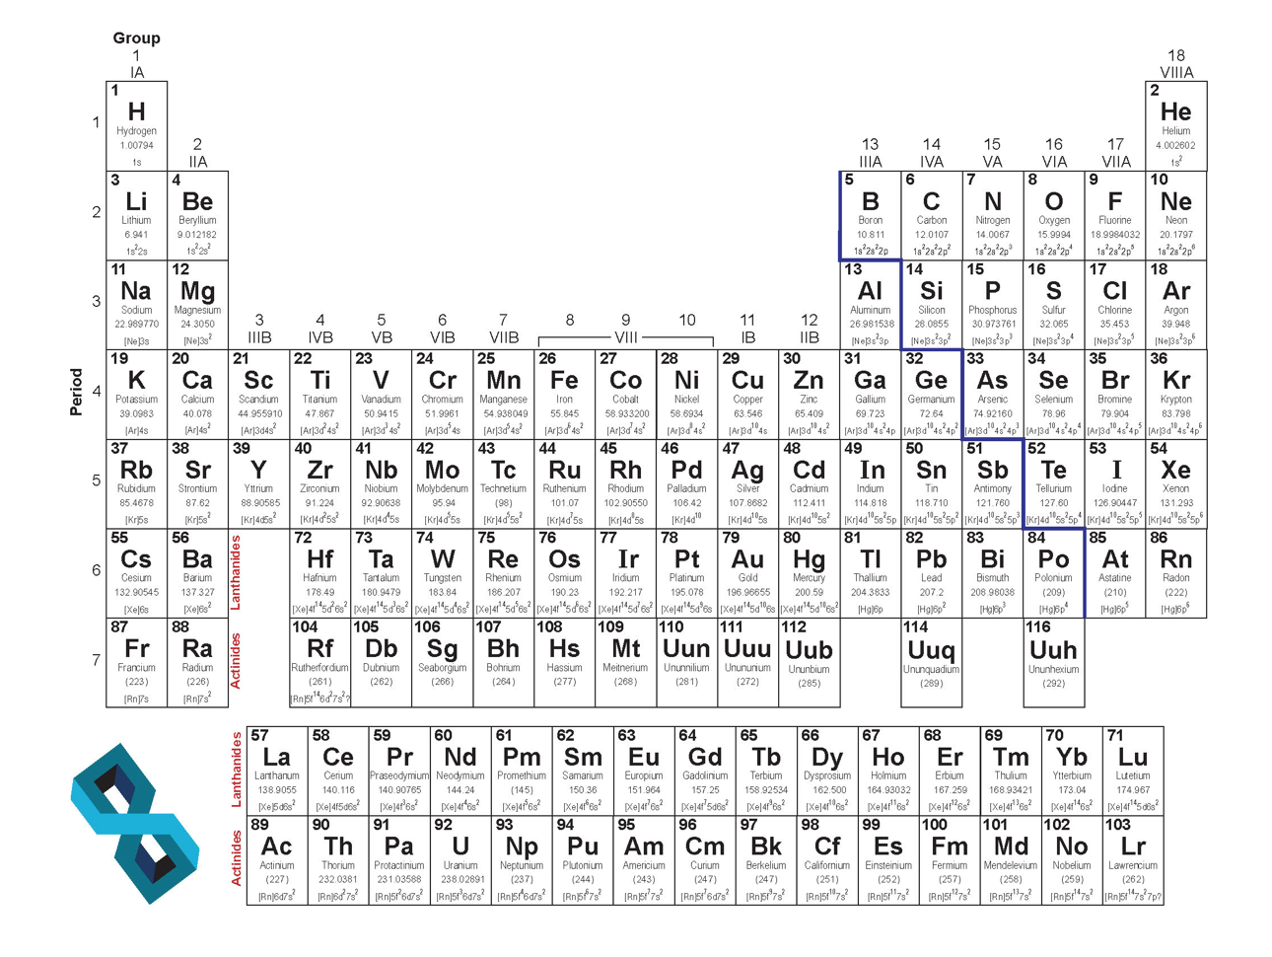

Atomic radius

Atomic radius



Electronegativity

Electronegativity

1. **How is a covalent bond different from an ionic bond?**

**A covalent bond is when to non-metals are held together through the sharing of electrons (via overlapping of orbitals). This results in an electronically neutral group of two or more atoms.**

**And Ionic bond is mainly different since its when a metal and non-metal are held together to form bonds.**

1. **Identify which compounds are covalently bonded and which ones have ionic bonds**

**Note to Instructor: Add your own structures**

1. **Using Lewis Dot Structures, show the sharing of electrons between a hydrogen atoms and a chlorine atom?**

Cl

H

**+**

Cl

H

**🡺**

1. **Draw the Lewis Dot Structure of Cl2. Label the bonding pairs and the lone pairs of electrons.**

Cl

Cl

1. **Draw the Lewis Dot Structure of methane and ethane. Label the bonding pairs and lone pairs of electrons.**

H

H

H

H

H

H

H

C

C

C

H

H

H

1. **Provide the correct nomenclature for the following compounds (common names are acceptable):**





 2,3-Dimethyl-1-hexene 6-Methyl-2-heptanol. 1-Chloro-3-methylcyclohexane

Benzene 1-Bromo-3-ethylcyclopentane 2,4-Heptadiene

1. **Draw the correct structures for the following names:**
2. **2,4-Dimethylheptane**
3. **2-Methyl-4-octene**
4. **1-Chloro-2-methylcyclopentane**







1. **Draw the correct structures for the following names:**
2. **Phenol**
3. **6-Methylheptanol**
4. **1-Methylcyclobutane**
5. **3-ethyl-2,4-dimethylhexane**
6. **3-ethyl-2-methylheptane**
7. **1-bromo-2-fluorocyclohexane**
8. **Cyclobutane**





1. **What is Biomimicry?**

Biomimicry is the approach to innovative novel materials and solutions for a more sustainable future by emulating nature and its intrinsic chemistry, systems and patterns.

1. **Name one type of way Green Chemistry is changing the way chemical reactions are performed.**

Refer to the 12 Principles of Green Chemistry. Ensure student directly correlates answers to any of the principles and explain their choice with an example.

1. **Why does Green Chemistry look at nature for future reactions? What does nature do that is hard to perform in the lab?**

Green Chemistry looks to nature since nature tends to be the most efficient at performing a wide range of chemical transformation at the fraction of the time. Furthermore, nature does everything at room temperature and with the highest selectivity and minimal waste.

1. **Name the following functional groups**



**Carboxylic acid nitrile ketone**

1. **Atorvastatin is a “statin” lowering drug what has a range of functional groups. Identify all the functional groups in the compound Atorvastatin.**

Amide

Alcohol

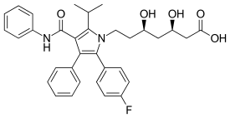

Carboxylic acid

Amine

Halogen

1. **Here is the structure of specialty compound that can be used in reversible reactions to block the amino acid residues in proteins. What functional groups are associated with this compound? (This one is tricky)**

Alkene



Acid Anhydride

1. **How many atoms are present in one mole (12g) of atomic carbon? Show all work for full points.**

**6.022 x 10^23 atoms**

1. **Answer the question for the reaction below:**

**KMnO4 + H2C2O4 + HCl 🡺 MnCl2 + CO2 + KCl + H2O**

1. Balance the equation (7 pts)

**2 KMnO4 + 5 H2C2O4 + 6 HCl 🡺 2 MnCl2 + 10 CO2 + 2 KCl + 8 H2O**

1. For a complete reaction of 1.5 mol of KMnO4, how many moles of H2C2O4 are needed (2 pts)?

3.75 moles

1. When 0.45 mol of CO2 are produced from the reaction, how many GRAMS of H2O are also produced (2 pts)?

6.48 grams of H20

1. How many moles of MnCl2 can be produced by the reaction of 5.0 mol of KMnO4 3 mol of H2C2O4 and 22 mol of HCl (2 pts)?
2. **The following reaction is the Diels-Alder reaction. Answer all question thoroughly to get maximum points.**



1. Write out the names of each molecule in this reaction

1,3-butene 1-triene 4-methylcyclohexene

1. If 400 g of the product was generated, how much total reagents are utilized if a yield of 82% is achieved?

Note: The diels-alder reaction is a 1:1 stiochiometric rection and a highly atom economical reaction.

Theoretical yield = 487.8g

400g of total reagents were utilized.

1. What is the atom economy of this reaction?

Theoretically, the atom economy is zero!!

1. **What is the Sustainability?**

Technologies and innovations that “Meeting the needs of the present generation without compromising the needs of future generations”

Technologies or innovations that inherently are safer for the environment without compromising performance.

1. **List the 12 Principles of Green Chemistry at align with Sustainability**

All of them!!

1. **What are the 3 criteria’s that sustainability tries to achieve?**

Social, Environment, and Profit

1. **What are the United Nations Sustainability Development Goals? Give two examples of UN Sustainability Development Goals that align with Green Chemistry.**

[GOAL 1: No Poverty](https://www.un.org/development/desa/disabilities/?page_id=6226&preview=true)

[GOAL 2: Zero Hunger](http://www.un.org/development/desa/disabilities/envision2030-goal2.html)

[GOAL 3: Good Health and Well-being](http://www.un.org/development/desa/disabilities/envision2030-goal3.html)

[GOAL 4: Quality Education](http://www.un.org/development/desa/disabilities/envision2030-goal4.html)

[GOAL 5: Gender Equality](http://www.un.org/development/desa/disabilities/envision2030-goal5.html)

[GOAL 6: Clean Water and Sanitation](http://www.un.org/development/desa/disabilities/envision2030-goal6.html)

[GOAL 7: Affordable and Clean Energy](http://www.un.org/development/desa/disabilities/envision2030-goal7.html)

[GOAL 8: Decent Work and Economic Growth](http://www.un.org/development/desa/disabilities/envision2030-goal8.html)

[GOAL 9: Industry, Innovation and Infrastructure](http://www.un.org/development/desa/disabilities/envision2030-goal9.html)

[GOAL 10: Reduced Inequality](http://www.un.org/development/desa/disabilities/envision2030-goal10.html)

[GOAL 11: Sustainable Cities and Communities](http://www.un.org/development/desa/disabilities/envision2030-goal11.html)

[GOAL 12: Responsible Consumption and Production](http://www.un.org/development/desa/disabilities/envision2030-goal12.html)

[GOAL 13: Climate Action](http://www.un.org/development/desa/disabilities/envision2030-goal13.html)

[GOAL 14: Life Below Water](http://www.un.org/development/desa/disabilities/envision2030-goal14.html)

[GOAL 15: Life on Land](http://www.un.org/development/desa/disabilities/envision2030-goal15.html)

[GOAL 16: Peace and Justice Strong Institutions](http://www.un.org/development/desa/disabilities/envision2030-goal16.html)

[GOAL 17: Partnerships to achieve the Goal](http://www.un.org/development/desa/disabilities/envision2030-goal17.html)

1. **Define Life Cycle Assessment.**

Compilation and evaluation of the inputs, outputs and the potential environmental impacts of a product system throughout its life cycle.

1. **Fill in the process diagram for the phases and stages of a full LCA**
2. **Why do companies perform LCA? List 2 of the 4 reasons.**

* Identify opportunities to improve environmental performance
* Inform decision-makers on “whole picture”
* Select relevant indicators of environmental performance
* Marketing e.g. ecolabels

1. **What is Circular Economy?**

A circular economy is an alternative to a traditional linear economy (make, use, dispose) in which we keep resources in use for as long as possible, extract the maximum value from them whilst in use, then recover and regenerate products and materials at the end of each service life.

1. **How is Circular Economy different from LCA?**

* LCA helps analyze the raw material usage and disposal, but neglects to connect disposal streams for other industries raw materials.
* Circular economy inherently tries to make the products from waste streams of other industries.
* Circular economy is a model for a true waste-to-value stream companies.

1. **Define a renewable resource/feedstock.**

Any resource/material that can be or will be replenish naturally in an set time frame. Not a one-time use material.

1. **What has to be satisfied to ensure a resource/feedstock as a viable renewable resource?**

The rate of growth/replenish must be fast than its depletion rate

Renewable resources CANNOT complete with food sources.

1. **Provide a list of 5 types of renewable resources used a to make platform materials**.

Sugars

Lignin

Cellulose

Pectin

Phenols

Chitosan

Starch

Collagen

1. **What is Pyrolysis?**

Pyrolysis is the heating of an organic material, such as biomass, in the absence of oxygen. In this treatment, material is exposed to high temperatures, and  go through chemical and physical separations to yield value-added molecules of different functionality.

1. **Explain the ABE process. What type of feedstock are needed for the process? Can it use renewable feedstocks to make bio-based ABE?**

The ABE process is a process that uses bacterial fermentation to produce acetone, n-butanol, and ethanol from carbohydrates such as starch and glucose.

Yes it can use both renewable feedstocks and thus making it bio-based.

1. **For companies who have won the Presidential Green Chemistry Awards, what were the benefits of implementing the 12 Principles of Green Chemistry**? Instructor may reference a specific case study that he/she assigns the class to read.
2. **For companies that have implemented Green Chemistry into their research, how has Green Chemistry saved money? Applying certain Principles are acceptable.**
3. **You are an intern at a chemical company. Shortly after starting, you noticed that the research lab wasn’t very concerned with the hazards associated with the products they were making. You noticed that solvent usage wasn’t a concern, chemists were producing a lot of organic waste, and the lab had a noticeable chemical odor. What 12 principles apply and could help the lab? Explain?**

Answers will vary significantly depending on the students answers. It is up to the professor/teaching faculty to evaluate the strength of the students answer.

1. **What is a Solvent?**

A solvent is a substance (typically a liquid) that dissolves a solute resulting in a solution.

1. **What are some everyday uses where solvents are vital?**

Paints

Degreasing

Dry Cleaning

Extractions

Beauty products

And….etc

1. **Chemistry/Functions behind solvents. Provide three reasons.**

Facilitate reagents into a common phase where they can react

Dissolve solids so that they can be pumped from location to another

Lower viscosity and easier mixing

Regulate temperatures of reactions

Allow recovery of solids by filtration

Extract compounds from mixtures

Recrystallization

Cleaning

1. **What are VOC’s? Why is it troublesome.**

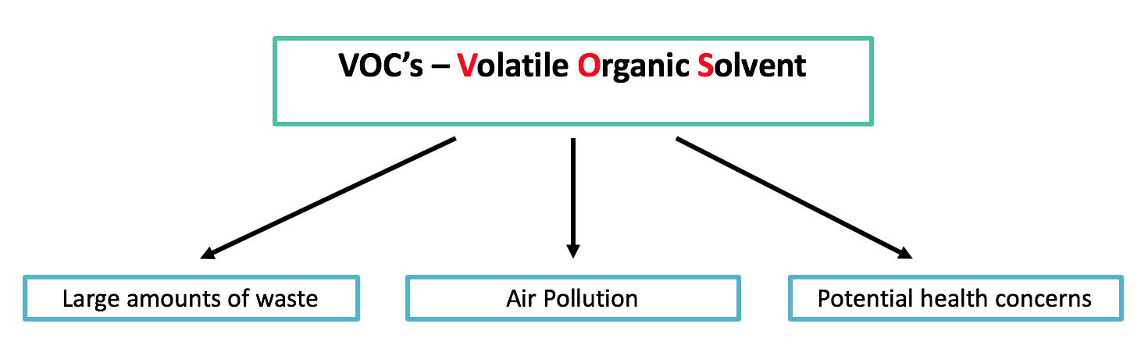

1. **What are the disadvantages of using solvents?**
2. When released into the air, nitrogen oxides react with escaped VOC’s to form ground-level ozone and smog
3. Destruction of the upper atmosphere
4. Toxicity and health risks to workers
   * Chlorinated and other solvents
   * Miscarriages
   * Birth defects
5. Risk of fires and explosions if VOC not controlled properly
6. Monetary Cost
7. **List 3 alternatives to performing chemistry without solvents.**
8. Supercritical Fluids
9. Ionic Liquids
10. Aqueous Chemistry
11. Solvent-Free processes
12. Mechanochemical Conditions
13. **How is a supercritical fluid defined?**

Supercritical Fluids are any substance at a temperature and pressure above its critical point, where distinct liquid and gas phases do not exist.

1. **Where on the phase transition graph is supercritical fluids?**



1. **What unique properties do supercritical fluids offer over traditional solvents?**

* Effuse through solids like a gas
* Small changes in pressure or temperature result in large changes in density, allowing many properties of a supercritical fluid to be "fine-tuned".
* A major advantage of supercritical solvents is their ease of removal. Simply decrease the pressure and vent off the gas.

1. **What are the disadvantages of supercritical fluids?**

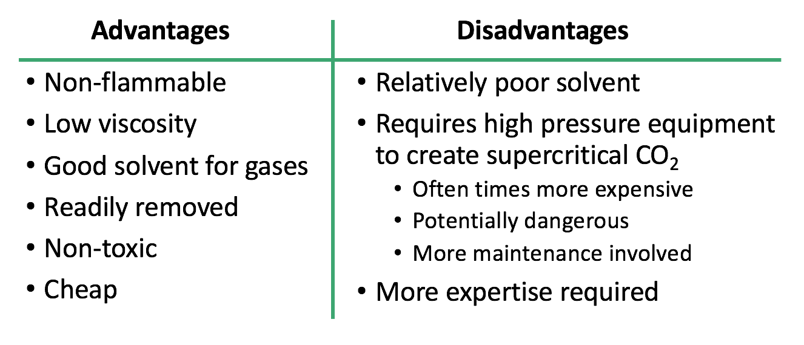

1. **What are ionic liquids? How are they green alternatives to solvents?**
2. **Advantages of Ionic Liquids?**

* Very low vapor pressure
* Can facilitate as a catalyst
* Viscosity is tunable
* High stability at high temperatures
* Readily prepared
* Recyclable!

1. **Disadvantages of Ionic Liquids?**

* Concerns with toxicity
* Non-biodegradable
* Synthesis requires haloalkanes
* Extraction and purification of IL’s requires organic solvents.

1. **Advantages to water-based chemistry?**

* Abundant
* Cheap
* Non-toxic
* Non-flammable
* High specific heat

1. **Disadvantages to water-based chemistry?**

* A lot of reagents and materials are water/moisture sensitive
* Generally poor solvent for organics
* Energy intensive
* Generated waste may be difficult to treat due to complexity.

1. **Explain what an extruder is? What type of chemistry can if facilitate.**

An extruder is an mechanical machines used to mix materials at high tension and pressure. An extruder has been demonstrated to be effective in facilitating solvent-free reactions.

1. **How does a ball-mill work for chemical reactions?**

**Motion → Friction → Heat → Reaction**

* Uses High Energy Ball Milling
* Vibrating ball mill crushes particles which results in large surface areas.
* Mixing of solids allows reaction at surfaces.
* High pressures are generated.

1. **Instead of the traditional heat, pressure, and mixing variables, what does a ball mill leverage to make chemical reactions happen?**

**Motion → Friction → Heat → Reaction**

* Uses High Energy Ball Milling
* Vibrating ball mill crushes particles which results in large surface areas.
* Mixing of solids allows reaction at surfaces.
* High pressures are generated.

1. **Explain catalysis.**

* Catalysis is the increase in the rate of a chemical reaction due to the participation of a catalyst.
* Scientifically, a catalyst allows for the lowering of the activation energy for a reaction to occur.
* Decreased activation energy results in faster and less energy intensive reactions and processes.

1. **Doesn’t adding a catalyst increase the amount of raw materials in any given process? Agree or disagree?**

Added benefits of a catalyst outweighs the addition of a new reagent.

1. **Advantages of using a catalyst?**

* energy required (e.g. heat)
* the use of stoichiometric reagents
* by-products
* waste.

1. **Disadvantages of catalysis?**

* Removal and separation of catalyst residues
* Recyclability of catalyst
* Degradation of catalyst over time.
* Potential toxicity to humans and the environment

1. **What are the two types of catalysis?**

Homogeneous and Heterogeneous catalysis

1. **What’s the difference between homogeneous and heterogeneous catalysis?**

**Homogeneous catalyst**

A catalytic reaction where the catalyst is in the SAME phase as the reactants. Ideally, the catalyst is soluble in a solution.

**Heterogeneous catalyst**

A catalytic reaction where the catalyst is in a DIFFERENT phase as the reactants. Ideally, the catalyst is immiscible in a solution and is a solid.

1. **Advantages and Disadvantages of catalysis?**

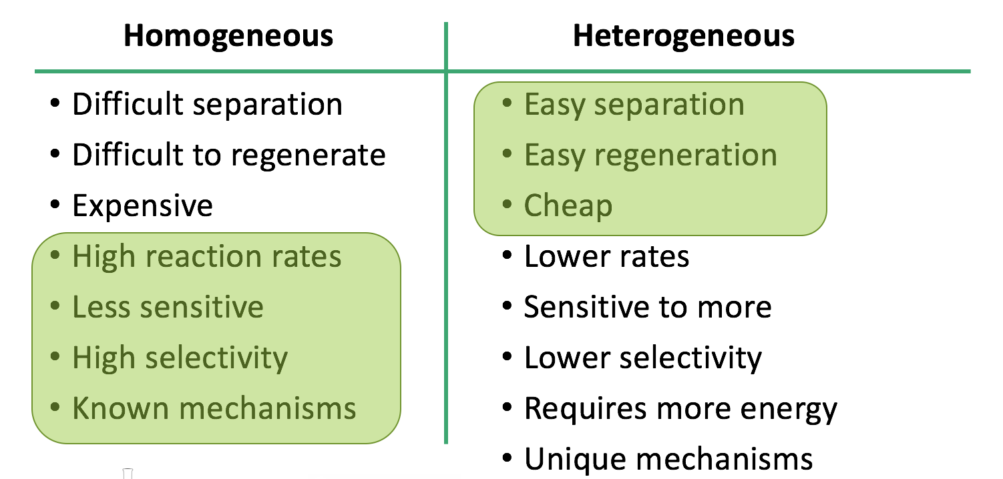

1. **Draw the reaction progress diagram showing a reaction with a catalyst and without a catalyst.**



1. **What is Biocatalysis?**

Biocatalysis is the chemical process through which enzymes or other biological catalysts perform reactions between organic components.

1. **Advantages and Disadvantages of using Biocatalysis?**

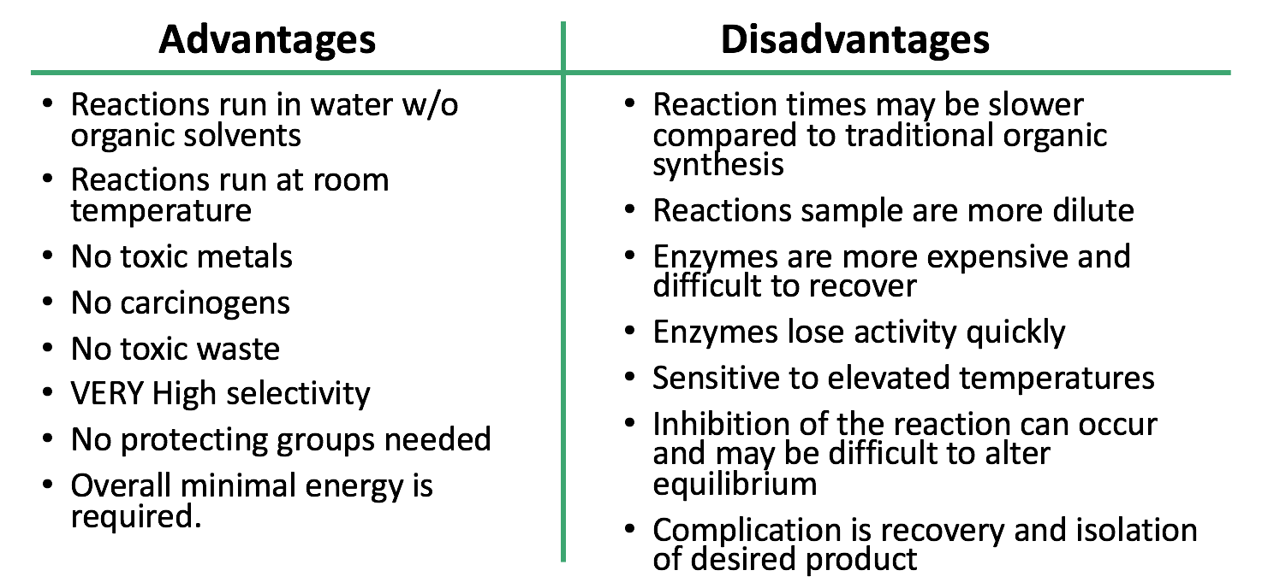

1. **How does the incorporation of Process Analytical Technology drives Green Chemistry in the scientific community?**

By reducing the hazards and risks of exposure to harmful chemicals and compounds.

1. **How is PAT safer for the environment and workers?**

PAT allows for the online and realtime monitoring of chemical transformations. By being able to monitor in real time is prevent the chances of run away reactions. It verifies the formation of the desired product while being in the reactor. This allows the worker to stop the reaction at any point to prevent waste and help increase the yield of the reaction.

1. **What is Toxicology?**

the study of the adverse effects of chemicals or physical agents on living organisms

1. **What is considered a toxic agent?**

A toxic agent is anything that can produce an adverse biological effect.

It may be chemical, physical, or biological in form.

For example, toxic agents may be

* chemical *(such as cyanide)*
* physical *(such as radiation)*
* biological *(such as snake venom)*

1. **Routes of exposure?**

Oral, Dermal, and Inhalation

1. **What is acute toxicity?**

Occurs immediately after exposure; acute exposure is a single dose or multiple doses within 24 hours

1. **What is chronic Toxicity?**

Cumulative damage to specific organ systems over months or years.

1. **What factors affect chemical toxicity?**

* Form and inherent chemical activity
* Dosage, especially dose-time relationship
* Exposure route
* Ability to be absorbed
* Metabolism rate
* Distribution within the body
* Excretion rate
* Presence of other chemicals
* Species
* Life stage
* Gender