**Questions: Note to instructor: Below is a list of questions that are suitable for a exam. You may select any number of question that you may feel is best suited for your class. This serves a mere guide and any additional questions are welcome.**

**Questions for Exam 2**

1. **What is the Sustainability?**

Technologies and innovations that “Meeting the needs of the present generation without compromising the needs of future generations”

Technologies or innovations that inherently are safer for the environment without compromising performance.

1. **List the 12 Principles of Green Chemistry at align with Sustainability**

All of them!!

1. **What are the 3 criteria’s that sustainability tries to achieve?**

Social, Environment, and Profit

1. **What are the United Nations Sustainability Development Goals? Give two examples of UN Sustainability Development Goals that align with Green Chemistry.**

[GOAL 1: No Poverty](https://www.un.org/development/desa/disabilities/?page_id=6226&preview=true)

[GOAL 2: Zero Hunger](http://www.un.org/development/desa/disabilities/envision2030-goal2.html)

[GOAL 3: Good Health and Well-being](http://www.un.org/development/desa/disabilities/envision2030-goal3.html)

[GOAL 4: Quality Education](http://www.un.org/development/desa/disabilities/envision2030-goal4.html)

[GOAL 5: Gender Equality](http://www.un.org/development/desa/disabilities/envision2030-goal5.html)

[GOAL 6: Clean Water and Sanitation](http://www.un.org/development/desa/disabilities/envision2030-goal6.html)

[GOAL 7: Affordable and Clean Energy](http://www.un.org/development/desa/disabilities/envision2030-goal7.html)

[GOAL 8: Decent Work and Economic Growth](http://www.un.org/development/desa/disabilities/envision2030-goal8.html)

[GOAL 9: Industry, Innovation and Infrastructure](http://www.un.org/development/desa/disabilities/envision2030-goal9.html)

[GOAL 10: Reduced Inequality](http://www.un.org/development/desa/disabilities/envision2030-goal10.html)

[GOAL 11: Sustainable Cities and Communities](http://www.un.org/development/desa/disabilities/envision2030-goal11.html)

[GOAL 12: Responsible Consumption and Production](http://www.un.org/development/desa/disabilities/envision2030-goal12.html)

[GOAL 13: Climate Action](http://www.un.org/development/desa/disabilities/envision2030-goal13.html)

[GOAL 14: Life Below Water](http://www.un.org/development/desa/disabilities/envision2030-goal14.html)

[GOAL 15: Life on Land](http://www.un.org/development/desa/disabilities/envision2030-goal15.html)

[GOAL 16: Peace and Justice Strong Institutions](http://www.un.org/development/desa/disabilities/envision2030-goal16.html)

[GOAL 17: Partnerships to achieve the Goal](http://www.un.org/development/desa/disabilities/envision2030-goal17.html)

1. **Define Life Cycle Assessment.**

Compilation and evaluation of the inputs, outputs and the potential environmental impacts of a product system throughout its life cycle.

1. **Fill in the process diagram for the phases and stages of a full LCA**

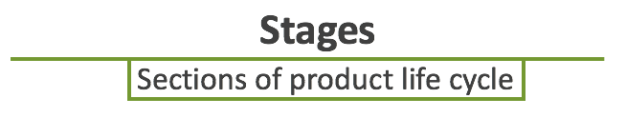

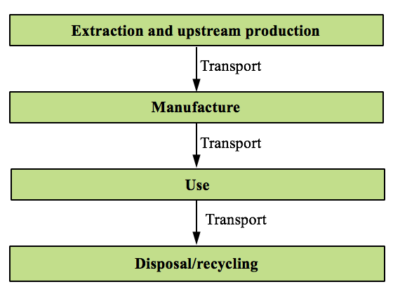

1. **Why do companies perform LCA? List 2 of the 4 reasons.**

* Identify opportunities to improve environmental performance
* Inform decision-makers on “whole picture”
* Select relevant indicators of environmental performance
* Marketing e.g. ecolabels

1. **What is Circular Economy?**

A circular economy is an alternative to a traditional linear economy (make, use, dispose) in which we keep resources in use for as long as possible, extract the maximum value from them whilst in use, then recover and regenerate products and materials at the end of each service life.

1. **How is Circular Economy different from LCA?**

* LCA helps analyze the raw material usage and disposal, but neglects to connect disposal streams for other industries raw materials.
* Circular economy inherently tries to make the products from waste streams of other industries.
* Circular economy is a model for a true waste-to-value stream companies.

1. **Define a renewable resource/feedstock.**

Any resource/material that can be or will be replenish naturally in an set time frame. Not a one-time use material.

1. **What has to be satisfied to ensure a resource/feedstock as a viable renewable resource?**

The rate of growth/replenish must be fast than its depletion rate

Renewable resources CANNOT complete with food sources.

1. **Provide a list of 5 types of renewable resources used a to make platform materials**.

Sugars

Lignin

Cellulose

Pectin

Phenols

Chitosan

Starch

Collagen

1. **What is Pyrolysis?**

Pyrolysis is the heating of an organic material, such as biomass, in the absence of oxygen. In this treatment, material is exposed to high temperatures, and  go through chemical and physical separations to yield value-added molecules of different functionality.

1. **Explain the ABE process. What type of feedstock are needed for the process? Can it use renewable feedstocks to make bio-based ABE?**

The ABE process is a process that uses bacterial fermentation to produce acetone, n-butanol, and ethanol from carbohydrates such as starch and glucose.

Yes it can use both renewable feedstocks and thus making it bio-based.

1. **For companies who have won the Presidential Green Chemistry Awards, what were the benefits of implementing the 12 Principles of Green Chemistry?** Instructor may reference a specific case study that he/she assigns the class to read.
2. **For companies that have implemented Green Chemistry into their research, how has Green Chemistry saved money? Applying certain Principles are acceptable.**

Answers will vary significantly depending on the students answers. It is up to the professor/teaching faculty to evaluate the strength of the students answer.

1. **You are an intern at a chemical company. Shortly after starting, you noticed that the research lab wasn’t very concerned with the hazards associated with the products they were making. You noticed that solvent usage wasn’t a concern, chemists were producing a lot of organic waste, and the lab had a noticeable chemical odor. What 12 principles apply and could help the lab? Explain?**

Answers will vary significantly depending on the students answers. It is up to the professor/teaching faculty to evaluate the strength of the students answer.

1. **What is a Solvent?**

A solvent is a substance (typically a liquid) that dissolves a solute resulting in a solution.

1. **What are some everyday uses where solvents are vital?**

Paints

Degreasing

Dry Cleaning

Extractions

Beauty products

And….etc

1. **Chemistry/Functions behind solvents. Provide three reasons.**

Facilitate reagents into a common phase where they can react

Dissolve solids so that they can be pumped from location to another

Lower viscosity and easier mixing

Regulate temperatures of reactions

Allow recovery of solids by filtration

Extract compounds from mixtures

Recrystallization

Cleaning

1. **What are VOC’s? Why is it troublesome.**

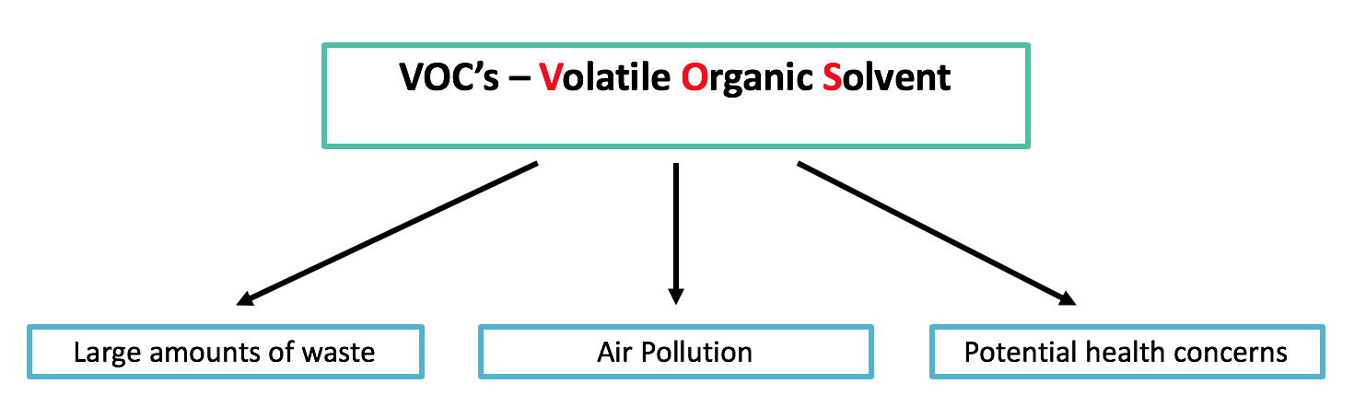

1. **Using the GlaxoSmithKline Solvent Guide. Which solvents have less issues.**

**Water, 1-butanol, 2-butanol, t-butyl acetate, isopropyl acetate, propyl acetate and dimethyl carbonate**

1. **What are the disadvantages of using solvents?**
2. When released into the air, nitrogen oxides react with escaped VOC’s to form ground-level ozone and smog
3. Destruction of the upper atmosphere
4. Toxicity and health risks to workers
   * Chlorinated and other solvents
   * Miscarriages
   * Birth defects
5. Risk of fires and explosions if VOC not controlled properly
6. Monetary Cost
7. **List 3 alternatives to performing chemistry without solvents.**
8. Supercritical Fluids
9. Ionic Liquids
10. Aqueous Chemistry
11. Solvent-Free processes
12. Mechanochemical Conditions
13. **How is a supercritical fluid defined?**

Supercritical Fluids are any substance at a temperature and pressure above its critical point, where distinct liquid and gas phases do not exist.

1. **Where on the phase transition graph is supercritical fluids?**



1. **What unique properties do supercritical fluids offer over traditional solvents?**

* Effuse through solids like a gas
* Small changes in pressure or temperature result in large changes in density, allowing many properties of a supercritical fluid to be "fine-tuned".
* A major advantage of supercritical solvents is their ease of removal. Simply decrease the pressure and vent off the gas.

1. **What are the disadvantages of supercritical fluids?**

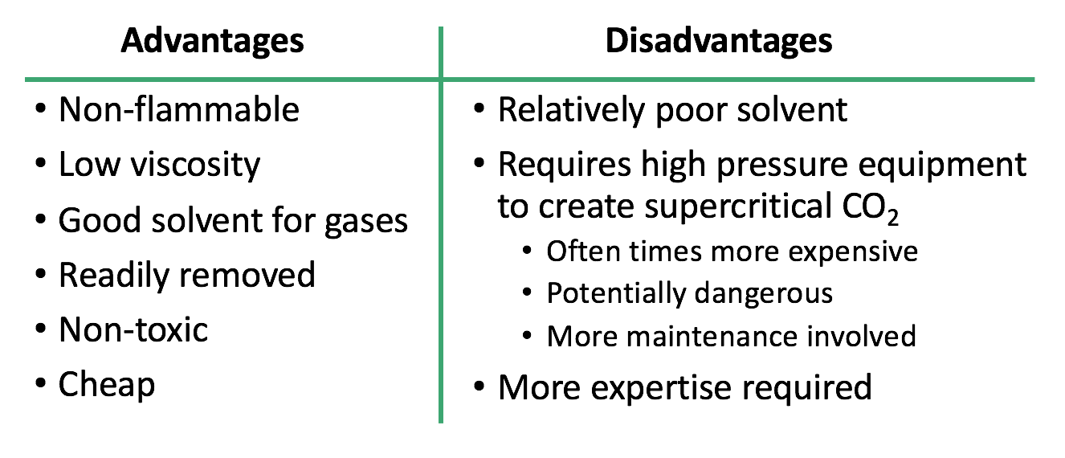

1. **What are ionic liquids? How are they green alternatives to solvents?**

**Ionic Liquids (IL’s) are salts which are fluids at ambient & room temperatures.**

**Ionic liquids consist of a mixture a positively charged molecule, i.e ammonium or phosphonium cation, and a negatively charged molecule, i.e anion.**

**They were originally considered green due to the non-volatility and non-flammability – but, some of them are concerning due to their toxicity and persistence**

1. **Advantages of Ionic Liquids?**

* Very low vapor pressure
* Can facilitate as a catalyst
* Viscosity is tunable
* High stability at high temperatures
* Readily prepared
* Recyclable!

1. **Disadvantages of Ionic Liquids?**

* Concerns with toxicity
* Non-biodegradable
* Synthesis requires haloalkanes
* Extraction and purification of IL’s requires organic solvents.

1. **Advantages to water-based chemistry?**

* Abundant
* Cheap
* Non-toxic
* Non-flammable
* High specific heat

1. **Disadvantages to water-based chemistry?**

* A lot of reagents and materials are water/moisture sensitive
* Generally poor solvent for organics
* Energy intensive
* Generated waste may be difficult to treat due to complexity.

1. **Explain what an extruder is? What type of chemistry can if facilitate.**

**Similar to the use of ball mills to enhance chemical reactions with high collisions, extruders use mechanical force to promote chemical transformations.**

**Extruders are used for:**

* + **Mixing, Pumping, Reactions & Polymer modifications, Polymer Blending**

1. **How does a ball-mill work for chemical reactions?**

**Motion → Friction → Heat → Reaction**

* Uses High Energy Ball Milling
* Vibrating ball mill crushes particles which results in large surface areas.
* Mixing of solids allows reaction at surfaces.
* High pressures are generated.

1. **Instead of the traditional heat, pressure, and mixing variables, what does a ball mill leverage to make chemical reactions happen?**

**Motion → Friction → Heat → Reaction**

* Uses High Energy Ball Milling
* Vibrating ball mill crushes particles which results in large surface areas.
* Mixing of solids allows reaction at surfaces.
* High pressures are generated.

1. **Explain catalysis.**

* Catalysis is the increase in the rate of a chemical reaction due to the participation of a catalyst.
* Scientifically, a catalyst allows for the lowering of the activation energy for a reaction to occur.
* Decreased activation energy results in faster and less energy intensive reactions and processes.

1. **Doesn’t adding a catalyst increase the amount of raw materials in any given process? Agree or disagree?**

Added benefits of a catalyst outweighs the addition of a new reagent.

1. **Advantages of using a catalyst?**

* energy required (e.g. heat)
* the use of stoichiometric reagents
* by-products
* waste.

1. **Disadvantages of catalysis?**

* Removal and separation of catalyst residues
* Recyclability of catalyst
* Degradation of catalyst over time.
* Potential toxicity to humans and the environment

1. **What are the two types of catalysis?**

Homogeneous and Heterogeneous catalysis

1. **What’s the difference between homogeneous and heterogeneous catalysis?**

**Homogeneous catalyst**

A catalytic reaction where the catalyst is in the SAME phase as the reactants. Ideally, the catalyst is soluble in a solution.

**Heterogeneous catalyst**

A catalytic reaction where the catalyst is in a DIFFERENT phase as the reactants. Ideally, the catalyst is immiscible in a solution and is a solid.

1. **Advantages and Disadvantages of catalysis?**

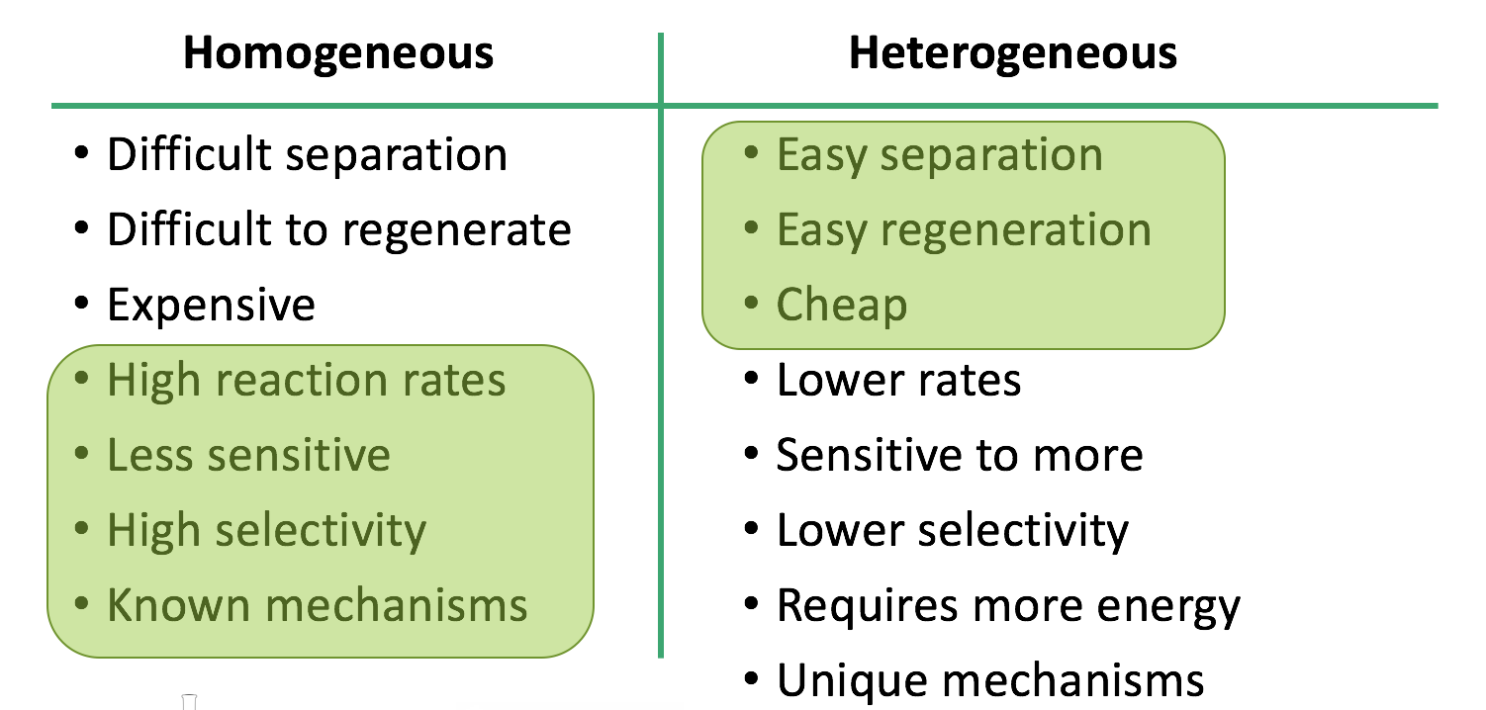

1. **Draw the reaction progress diagram showing a reaction with a catalyst and without a catalyst.**

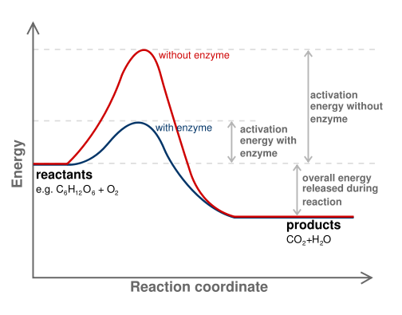

In this case, the enzyme is the catalyst! Students can draw a generic reaction coordinate diagram showing the lowering of the activation energy due to a catalyst.

**Image:** [**https://commons.wikimedia.org/wiki/File:Activation2_updated.svg**](https://commons.wikimedia.org/wiki/File:Activation2_updated.svg)

1. **What is biocatalysis?**

Biocatalysis is the chemical process through which enzymes or other biological catalysts perform reactions between organic components.

1. **Advantages and Disadvantages of using biocatalysis?**

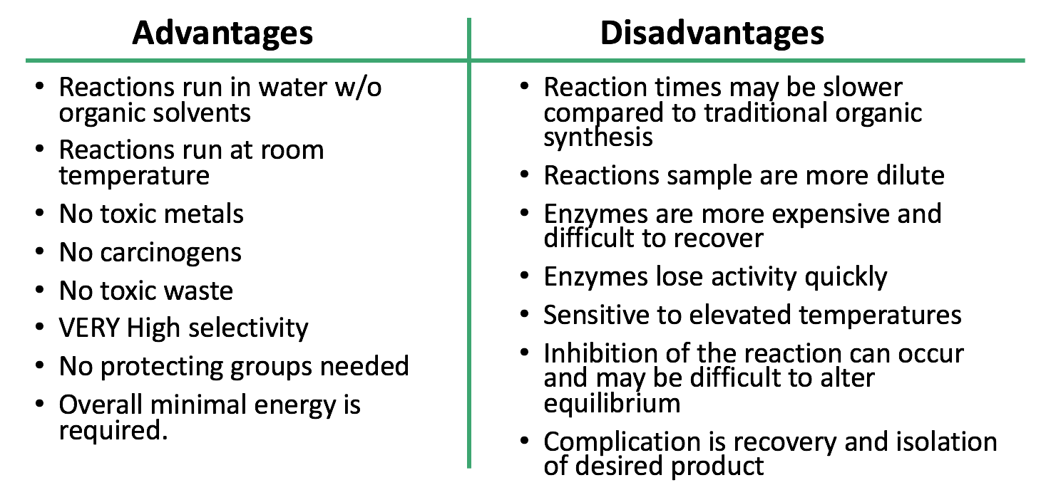

**Previous exam question to ensure student understand nomenclature and structures**

1. **Provide the correct nomenclature for the following compounds (common names are acceptable):**





2,3-Dimethyl-1-hexene 6-Methyl-2-heptanol. 1-Chloro-3-methylcyclohexane 

Benzene 1-Bromo-3-ethylcyclopentane 2,4-Heptadiene

1. **Draw the correct structures for the following names:**
2. **2,4-Dimethylheptane**
3. **2-Methyl-4-octene**
4. **1-Chloro-2-methylcyclopentane**





1. **Draw the correct structures for the following names:**
2. **Phenol**
3. **6-Methylheptanol**
4. **1-Methylcyclobutane**
5. **3-ethyl-2,4-dimethylhexane**
6. **3-ethyl-2-methylheptane**
7. **1-bromo-2-fluorocyclohexane**
8. **Cyclobutane**





1. **Name one type of way Green Chemistry is changing the way chemical reactions are performed.**

Refer to the 12 Principles of Green Chemistry. Ensure student directly correlates answers to any of the principles and explain their choice with an example.

1. **Why does Green Chemistry look at nature for future reactions? What does nature do that is hard to perform in the lab?**

Green Chemistry looks to nature since nature tends to be the most efficient at performing a wide range of chemical transformation at the fraction of the time. Furthermore, nature does everything at room temperature and with the highest selectivity and minimal waste.

1. **Name the following functional groups**



**Carboxylic acid nitrile ketone**

1. **Atorvastatin is a “statin” lowering drug what has a range of functional groups. Identify all the functional groups in the compound Atorvastatin.**

Amide

Alcohol

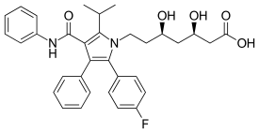

Carboxylic acid

Amine

Halogen

1. **Here is the structure of specialty compound that can be used in reversible reactions to block the amino acid residues in proteins. What functional groups are associated with this compound? (This one is tricky)**

Alkene



Acid Anhydride