**Homework 1 - Molecules and Organic Nomenclature**

**Description:**

In this assignment, you will have the opportunity to practice and apply your nomenclature knowledge to a range of questions.

**Questions: Note to instructor: Below is a list of questions that are suitable for a homework assignment. You may select any number of question that you may feel is best suited for your class. This serves a guide and additional questions are welcome.**

1. **Name the functional groups appropriately**







**_Alcohol_ _Amide_ _Aldehyde_ _Halogen _ _Ether_**

1. **Draw out the correct functional group:**
   1. 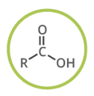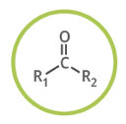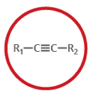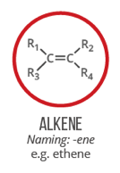Alkene
   2. Alkyne
   3. Ketone
   4. Carboxylic Acid
   5. 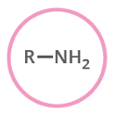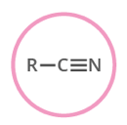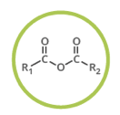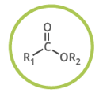Ester
   6. Acid Anhydride
   7. Nitrile
   8. Amine
2. **Identify and label all functional groups in Rivaroxaban (Xarelto).**

Halogen

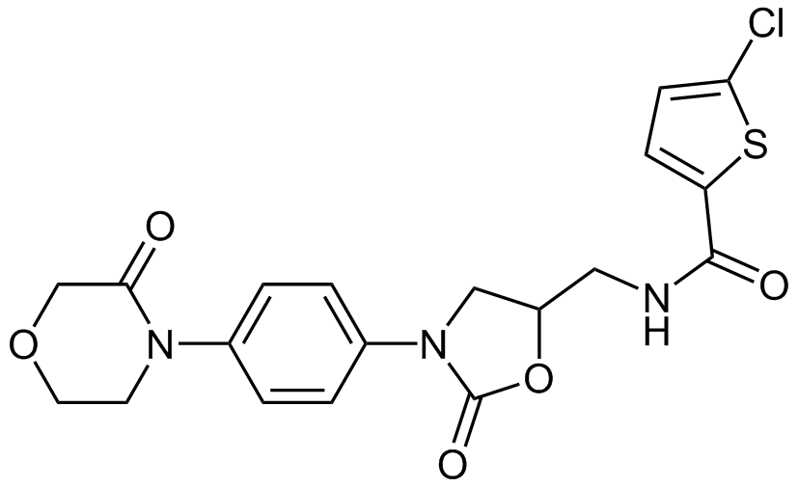

Amine

Amide

1. **Provide the correct names for the following compounds:**

|  |  |  |  |
| --- | --- | --- | --- |
|  |  |  |  |
|  |  |  | Hint: -OH would be a sidechain in this case and it’s called “hydroxyl” |
|  |  |  |  |

**Answers:**

2-ethylhexanal, 5-hydroxy-6-methylheptanal, 4,5-dichloro-2-methyloctan-3-ol, *N,N*-diethylpentanamide, 2-chloro-6-ethylphenol, 2,3-dichloro-4-methylphenol, *N*-ethyl-3,4-dimethylpentanamide, 3-chlorobutanal, 6-chloroheptan-3-one, methyl 4-bromopentanoate, 2,4,5-trimethyloctan-3-ol, 3-chloro-2-methylcyclohexan-1-amine.