**Questions: Note to instructor: Below is a list of questions that are suitable for a final exam. You may select any number of question that you may feel is best suited for your class. This serves a mere guide and any additional questions are welcome. The final exam is an accumulation of previous exams. Additional questions by instructors is encouraged.**

**Questions for Final Exam**

1. **What is the Definition of Green Chemistry?**
2. **List 6 of the 12 Principles of Green Chemistry**
3. **What are the 3 Pillars of Green Chemistry?**
4. **What happened in 1984 in Bhopal, India?**
5. **Explain**
6. **Fill in the blanks:**
7. **Risk = ____ + _____**
8. **How does Green Chemistry reduce Risk?**
9. **For companies who have won the Presidential Green Chemistry Awards, what were the benefits of implementing the 12 Principles of Green Chemistry?** Instructor may reference a specific case study that he/she assigns the class to read.
10. **For companies that have implemented Green Chemistry into their research, how has Green Chemistry saved money? Applying certain Principles are acceptable.**
11. **You are an intern at a chemical company. Shortly after starting, you noticed that the research lab wasn’t very concerned with the hazards associated with the products they were making. You noticed that solvent usage wasn’t a concern, chemists were producing a lot of organic waste, and the lab had a noticeable chemical odor. What 12 principles apply and could help the lab? Explain?**
12. **What is matter? What is the fundamental unit of matter?**
13. **Which of the following represents an element and which of the follow represent a compound? Write answer below symbol**
14. **C b. He c. BaCl d. CF4**
15. **Which of the following represents an element and which of the follow represent a compound? Write answer below symbol**
16. **CO2 b. Li c. CaCO3 d. FeO**
17. **Name the following elements:**
18. **Ti b. Ba c. Pb d. Ag**
19. **Write the symbol for each of the following elements:**
20. **Nitrogen b. Silver c. Mercury d. Argon**
21. **What does the picture below represent? Label all appropriate**

AN

E

MN

1. **What does the mass number represent?**
2. **What does the atomic number represent?**
3. **What are the differences between Proton? Electron? Neutron?**
4. **Where to Protons, Electrons, and Neutrons reside in the atom?**
5. **A neutral atom with 9 protons will have how many electrons?**
6. **What is the isotropic symbol of the element that has 44 protons in the nucleus of its atom.**
7. **What is the most abundant element on the earth?**
8. **When an atom loses 2 electrons, the charge on its ion is? Is the new ion species a cation or anion?**
9. **An atom of an element has 2 electrons in the first valence shell, eight in the second valence shell, and 4 in the third shell. With this information, give the elements (a) name, (b) atomic number, (c) written out in its ion form, (d) location on periodic table.**
10. **Indicate the trend of atomic radius and electronegativity across the periodic table. Use arrows to show increasing tendency across rows and columns for these parameters.**

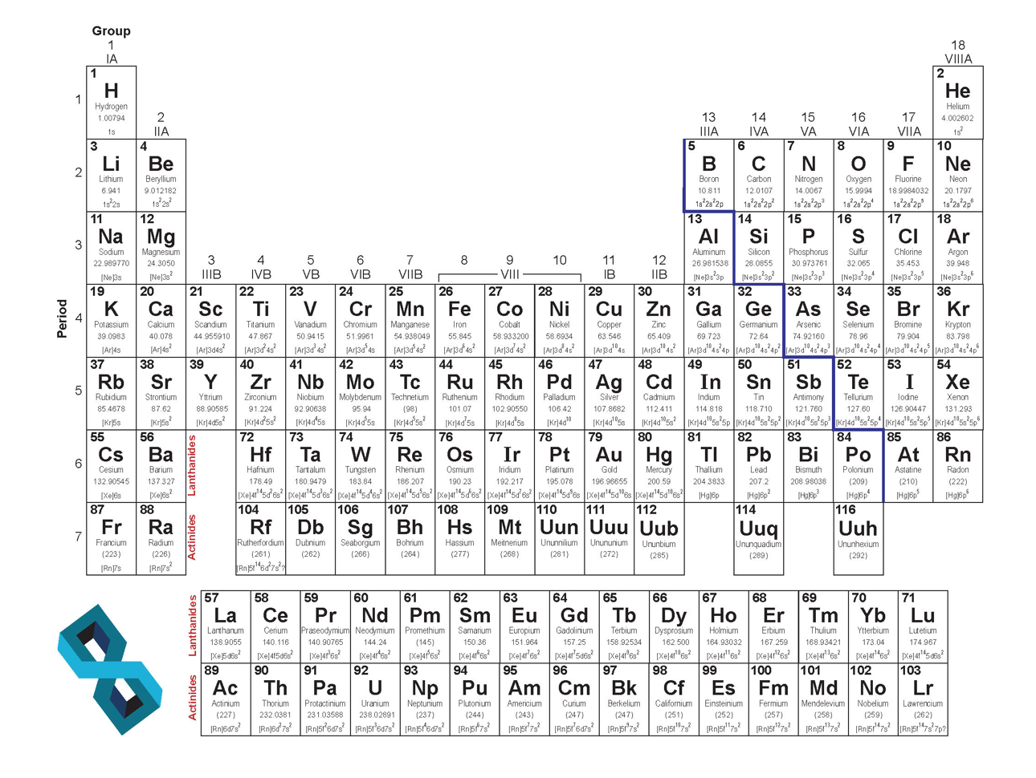

1. **How is a covalent bond different from an ionic bond?**
2. **Identify which compounds are covalently bonded and which ones have ionic bonds**

**Add Structures**

1. **Using Lewis Dot Structures, show the sharing of electrons between a hydrogen atoms and a chlorine atom?**
2. **Draw the Lewis Dot Structure of Cl2. Label the bonding pairs and the lone pairs of electrons.**
3. **Draw the Lewis Dot Structure of methane and ethane. Label the bonding pairs and lone pairs of electrons.**
4. **Provide the correct nomenclature for the following compounds (common names are acceptable):**







1. **Draw the correct structures for the following names:**
2. **2,4-Dimethylheptane**
3. **2-Methyl-4-octene**
4. **1-Chloro-2-methylcyclopentane**
5. **Draw the correct structures for the following names:**
6. **Phenol**
7. **6-Methylheptanol**
8. **1-Methylcyclobutane**
9. **3-ethyl-2,4-dimethylhexane**
10. **3-ethyl-2-methylheptane**
11. **1-bromo-2-fluorocyclohexane**
12. **Cyclobutane**
13. **What is Biomimicry?**
14. **Name one type of way Green Chemistry is changing the way chemical reactions are performed.**
15. **Why does Green Chemistry look at nature for future reactions? What does nature do that is hard to perform in the lab?**
16. **Name the following functional groups**



1. **Atorvastatin is a “statin” lowering drug what has a range of functional groups. Identify all the functional groups in the compound Atorvastatin.**

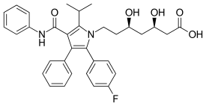

1. **Here is the structure of specialty compound that can be used in reversible reactions to block the amino acid residues in proteins. What functional groups are associated with this compound? (This one is tricky)**



1. **How many atoms are present in one mole (12g) of atomic carbon? Show all work for full points.**
2. **Answer the question for the reaction below:**

**KMnO4 + H2C2O4 + HCl 🡺 MnCl2 + CO2 + KCl + H2O**

1. Balance the equation (7 pts)
2. For a complete reaction of 1.5 mol of KMnO4, how many moles of H2C2O4 are needed (2 pts)?
3. When 0.45 mol of CO2 are produced from the reaction, how many GRAMS of H2O are also produced (2 pts)?
4. How many moles of MnCl2 can be produced by the reaction of 5.0 mol of KMnO4 3 mol of H2C2O4 and 22 mol of HCl (2 pts)?
5. How many grams of MnCl2 will be produced from the complete conversion of 30 g of KMnO4, 22 g of H2C2O4 and 56 g of HCl (5 pts)?
6. How much of each reagent will be leftover (2 pts)?
7. **The following reaction is the Diels-Alder reaction. Answer all question thoroughly to get maximum points.**



1. Write out the names of each molecule in this reaction
2. If 400 g of the product was generated, how much of each reagent are utilized if a yield of 82% is achieved?
3. What is the atom economy of this reaction?
4. **What is the Sustainability?**
5. **List the 12 Principles of Green Chemistry at align with Sustainability**
6. **What are the 3 criteria’s that sustainability tries to achieve?**
7. **What are the United Nations Sustainability Development Goals? Give two examples of UN Sustainability Development Goals that align with Green Chemistry.**
8. **Define Life Cycle Assessment.**
9. **Fill in the process diagram for the phases and stages of a full LCA**
10. **Why do companies perform LCA? List 2 of the 4 reasons.**
11. **What is Circular Economy?**
12. **How is Circular Economy different from LCA?**
13. **Define a renewable resource/feedstock.**
14. **What has to be satisfied to ensure a resource/feedstock as a viable renewable resource?**
15. **Provide a list of 5 types of renewable resources used a to make platform materials**.
16. **What is Pyrolysis?**
17. **Explain the ABE process. What type of feedstock are needed for the process? Can it use renewable feedstocks to make bio-based ABE?**
18. **For companies who have won the Presidential Green Chemistry Awards, what were the benefits of implementing the 12 Principles of Green Chemistry?** Instructor may reference a specific case study that he/she assigns the class to read.
19. **For companies that have implemented Green Chemistry into their research, how has Green Chemistry saved money? Applying certain Principles are acceptable.**
20. **You are an intern at a chemical company. Shortly after starting, you noticed that the research lab wasn’t very concerned with the hazards associated with the products they were making. You noticed that solvent usage wasn’t a concern, chemists were producing a lot of organic waste, and the lab had a noticeable chemical odor. What 12 principles apply and could help the lab? Explain?**
21. **What is a Solvent?**
22. **What are some everyday uses where solvents are vital?**
23. **Chemistry behind solvents. Provide three reasons.**
24. **What are VOC’s? Why is it troublesome.**
25. **Using the GlaxoSmithKline Solvent Guide. Which solvents have less issues.**
26. **What are the disadvantages of using solvents?**
27. **List 3 alternatives to performing chemistry without solvents.**
28. **How is a supercritical fluid defined?**
29. **Where on the phase transition graph is supercritical fluids?**
30. **What unique properties do supercritical fluids offer over traditional solvents?**

1. **What are the disadvantages of supercritical fluids?**
2. **What are ionic liquids? How are they green alternatives to solvents?**
3. **Advantages of Ionic Liquids?**
4. **Disadvantages of Ionic Liquids?**
5. **Advantages to water-based chemistry?**
6. **Disadvantages to water-based chemistry?**
7. **Explain what an extruder is? What type of chemistry can if facilitate.**
8. **How does a ball-mill work for chemical reactions?**
9. **Instead of the traditional heat, pressure, and mixing variables, what does a ball mill leverage to make chemical reactions happen?**
10. **Explain catalysis.**
11. **Doesn’t adding a catalyst increase the amount of raw materials in any given process? Agree or disagree?**
12. **Advantages of using a catalyst?**
13. **Disadvantages of catalysis?**
14. **What are the two types of catalysis?**
15. **What’s the difference between homogeneous and heterogeneous catalysis?**
16. **Advantages and Disadvantages of catalysis?**
17. **Draw the reaction progress diagram showing a reaction with a catalyst and without a catalyst.**
18. **What is Biocatalysis?**
19. **Advantages and Disadvantages of using Biocatalysis?**
20. **How does the incorporation of Process Analytical Technology drives Green Chemistry in the scientific community?**
21. **How is PAT safer for the environment and workers?**
22. **What is Toxicology?**
23. **What is considered a toxic agent?**
24. **Routes of exposure?**
25. **What is acute toxicity?**
26. **What is chronic Toxicity?**
27. **What factors affect chemical toxicity?**