GREEN CHEMISTRY
Train the Facilitator Workshop
Dates: 6th to 11th January’2019, Venue: Renuka Hotel

PROGRAMME
DAY 1
08:00-08:30 | Registration
08:30 - 09:00 | Welcome  Welcome by Representatives of National Cleaner Production Center, Sri Lanka  Karolina Mellor, Center for Green Chemistry & Green Engineering at Yale
09:00 – 10:30 | Morning Session I: Sustainability 1  - Sustainability – Myths and Facts  - Society, Economy, and the Environment
10:30 - 10:45 | Tea/ Health Break
10:45 - 12:15 | Morning Session II: Sustainability 2  - Business and Sustainability  - Applying Green Chemistry to Management  - Different Models of Sustainability  - Case Study: The Interface Company  - In-Class Discussion
12:15 – 13:15 | Lunch
13:15 – 14:45 | Afternoon Session I: Sustainability 3  - Describe Processes for Reporting and Measuring Sustainable Actions  - Life Cycle Assessment  - Definitions & Examples  - In-Class Exercise
14:45 -15:00 | Tea / Health Break
15:00 – 16:30 | Afternoon Session II: Disasters and Unintended Consequences  - Chemical and Industrial Accidents  - Union Carbide, 1984  - Cuyahoga River, 1969  - Port of Tianjin, 2015  - Unintended Consequences  - Green Chemistry is Everybody’s Job  - Perspective and Context  - Green Chemistry – Where do we go from here?
16:30 | Break for the day
DAY 2
09:00 – 10:30 | Morning Session I: Definitions & Benefits of Green Chemistry  - What is Green Chemistry  - Twelve Principles of Green Chemistry  - Chemical and Green Chemistry Design  - The Market and Demand for Green Chemistry  - Examples of the Twelve Principles
10:30 - 10:45 | Tea/ Health Break
10:45 - 12:15 | Morning Session II: Metrics  - Conventional Chemistry Metrics  - Why do we need Metrics in Green Chemistry?  - Metrics used in Green Chemistry  - Atom Economy  - Environmental (E) Factor  - Process Mass Intensity  - In Class Discussion
12:15 – 13:15 | Lunch
13:15 – 14:45 | Afternoon Session I: Waste  - Appraoches to deal with Environmental Challenges  - The Waste Treatment Pyramid  - Reduced Solvent Use  - Waste as a Feedstock  - Biodegradation of Waste  - Biodegradation Exercise
14:45 -15:00 | Tea / Health Break
15:00 – 16:30 | Afternoon Session II: Renewable Feedstocks for Energy  - Energy from Fossil Feedstocks  - First, Second, and Third Generation Feedstocks  - The Advantages and Drawbacks of Biofuel
16:30 | Break for the day
DAY 3
09:00 – 10:30 | Morning Session I: Renewable Feedstocks for Molecules  - Petroleum Chemistry  - The Biorefinery  - Renewable Feedstocks  - Biomass Feedstocks  - Carbohydrate Feedstocks  - Triglycerides Feedstock  - Lignocellulosic Feedstock  - Protein Feedstocks  - Renewable Feedstocks as a Source of Molecules  - A Little History of Vanillin  - Platform Molecules  - Advantages & Drawbacks of bio-based Molecules
10:30 - 10:45 | Tea/ Health Break
10:45 - 12:15 | Morning Session II: Catalysis  - Activation Energy for Reaction  - What is a Catalyst?  - Types of Catalysts  - Catalysts and Sustainability  - Important Improvements Using Catalysts  - Enzymatic Reactions  - Examples and Considerations
12:15 – 13:15 | Lunch
13:15 – 14:45 | Morning Session I: Solvents  - What are solvents and how are they used?  - Conventional Solvents  - Alternative Solvents  - Solvent Selection  - In-Class Exercise  - Solvent Replacement
14:45 -15:00 | Tea / Health Break
15:00 – 16:30 | Afternoon Session II: Energy Delivery in Chemistry  - Role of Energy in a Chemical Process  - Microwaves  - Flow Chemistry  - Photochemistry  - Electrochemistry  - Mechanochemistry
16:30 | Break for the day
DAY 4
09:00 – 10:30 | Morning Session I: Designing for Reduced Hazard 1  - Hazard and Risk – Past and Present  - Toxicology  - In-Class Discussion  - Assessing Hazards and Exposure  - What Happens When You’re Exposed?
10:30 - 10:45 | Tea/ Health Break
10:45 - 12:15 | Morning Session II: Designing for Reduced Hazard 2  - In-Class Exercise  - Hazard Minimisation Through Molecular Design  - QSAR-Quantitative Structure Activity Relationship
12:15 – 13:15 | Lunch
13:15 – 14:45 | Afternoon Session I: From Theory to Practice  - Implementation: Why, What, and How  - Understanding Context  - Green Chemistry in the Marketplace  - Identify Opportunities  - Life Cycle and Green Chemistry Principles as a Guide to Finding Opportunity  - Delivering Innovation  - Green Chemistry Strategies at All Stages  - Green Chemistry Assessment Tool  - How to Proceed: Moving Forward
14:45 -15:00 | Tea / Health Break
15:00 – 16:30 | Afternoon Session II: Innovation  - Transformative Innovation  - What is it that we really want?  - Nature as Inspiration  - Design Challenges  - Biomimicry  - Colour  - Adhesives  - Self-Cleaning  - There is Still More We Can Learn from Nature
16:30 | Break for the day

DAY 5
09:00 – 10:30 | Morning Session I: Conducted by Prof Ajith de Alwis , Professor Chemicals and Process Engineering, University of Moratuwa  Learning about Green Chemistry Landscape  Discuss Challenges and Opportunities
10:30 - 10:45 | Tea/ Health Break
10:45 - 12:15 | Morning Session II: Partner’s Case study by UNION CHEMICALS PLC & Dyna washing Ltd
12:15 – 13:15 | Lunch
13:15 – 14:45 | Afternoon Session I: Lessons Learned and the Path Forward  Session moderate by Eng. Samantha Kumarasena, CEO, NCPCSL
 | Closing Remarks

FACILITATORS PROFILE:

Professor Audrey Moores

Audrey Moores is an Associate Professor of Chemistry and Tier II Canada Research Chair in Green Chemistry (2007-17) at McGill University. She is a leading expert in the field of catalysis using metal, metal oxide and biomass-based nanomaterials, with a special emphasis on sustainable processes and use of earth abundant starting materials. Her research was recently highlighted in Nature in 2016, and she was selected as an emerging leader in 2017 by the RSC journal Green Chemistry.

Career
She is the scientific director in the board of GreenCenter Canada, an Ontario-based tech transfer company, and the associate director of the Facility for Electron Microscopy Research (FEMR) at McGill since 2017. She is a member of the advisory board of the Green Chemistry Institute (America Chemical Society) since 2018. Since 2016, she is an associate editorship for ACS Sustainable Chemistry & Engineering.
She received a Discovery Accelerator Supplement Award in 2018 from the Natural Sciences and Engineering Research Council of Canada. She was recently invited by the United Nations Industrial Development Organization for to teach a 5-day workshop in South Africa in the fall 2018.
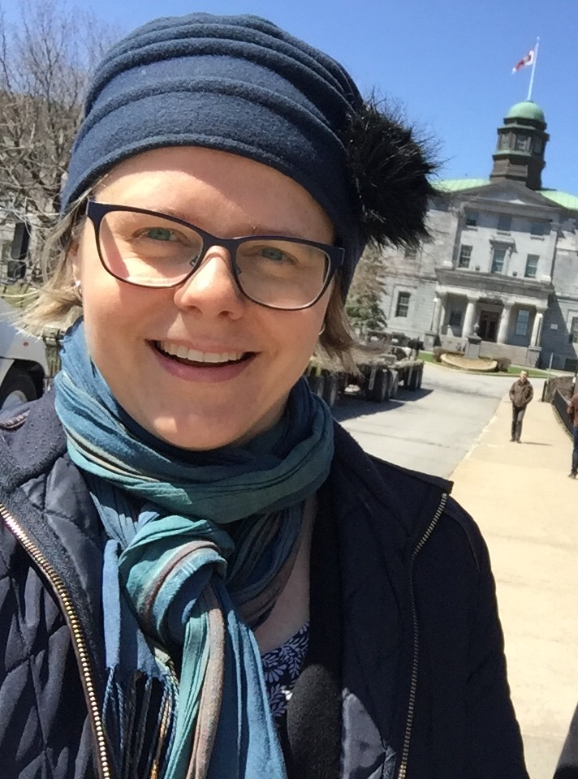

Dr Karolina Mellor

Karolina Meloor in a Program Manager, Education Lead, Center for Green Chemistry & Green Engineering at Yale University with experience in green chemistry education and research. She joined the Center 5 years ago and coordinated multiple projects, including Global Green Chemistry Initiative.

Karolina has many roles in the Center for Green Chemistry & Green Engineering including operations, outreach and development, but her primary role is to lead educational efforts in green chemistry. She translates research into teaching tools to educate diverse audiences in green chemistry and sustainability. Her expertise includes online/traditional teaching and instructional design, educational games development and workshop design.

Before coming to Yale, Karolina received her Ph.D. in molecular biology from the University of Virginia. She also worked at the University Innovation Licensing and Ventures Group where she evaluated patent strategies and explored commercial potential of technologies developed at the university.

