Design for Biodegradability

Toxicology Concept: Biodegradability; Persistence

Literature Article/Reference: Boethling, R.S., Sommer, E., and DiFiore, D., Chem. Reviews, 2007, Vol. 107, No. 6, 2207-2227

Background: Design rules for biodegradability:
There are general rules of thumb for biodegradability that have been developed based on observing how different chemical structures persist or degrade under certain conditions. The biodegradability of a molecule can be due to the structure itself, but will also be affected by the conditions or environment in which the molecule resides (i.e., environment, waste treatment, etc.). Aerobic biodegradation is degradation with oxygen present. There are some general rules for understanding how structural features will either increase or decrease biodegradation. Understanding these rules can help chemists to identify molecules that are likely to persist and be resistant to biodegradation.

Features that increase resistance to aerobic biodegradation:
Feature | Structure
Halogens: Especially chlorine and fluorine and if more than 3 in a molecule | 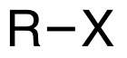
Chain branching if extensive: Quaternary C’s are problematic | 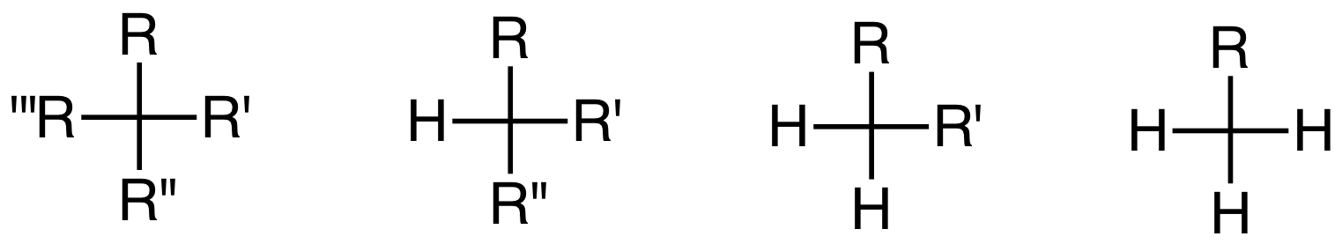
Tertiary amine, nitro, nitroso, azo, and arylamino groups | 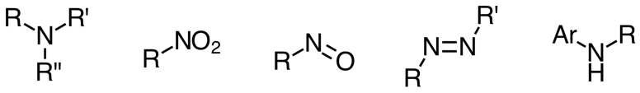
Polycyclic aromatic residues | 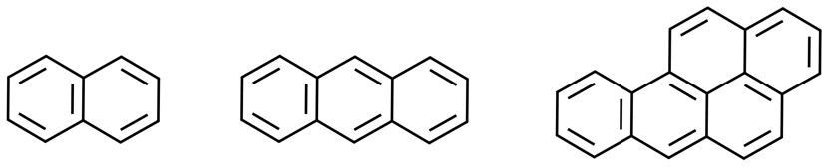
Heterocyclic residues | 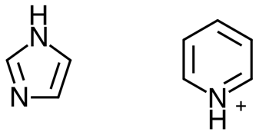
Aliphatic ether bonds (except in ethoxylates) | 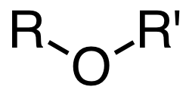

Molecular features that generally increase aerobic biodegradability:
Feature | Structure
Groups susceptible to enzymatic hydrolysis (esters, including phosphate esters) and amides | 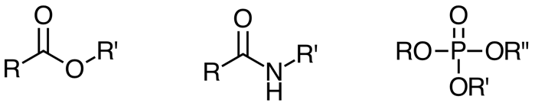
Oxygen atoms in the form of hydroxyl, aldehyde, or carboxylic acid groups, ketones (not ether, with the exception of ethoxylate groups) | 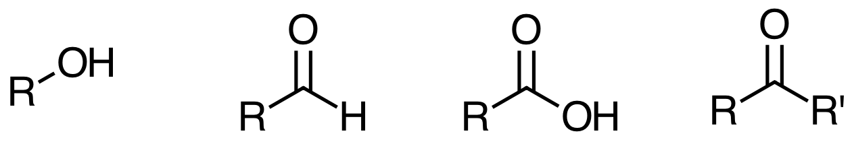  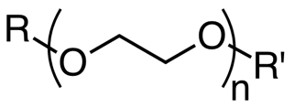
Unsubstituted linear alkyl chains (especially ≥ 4 carbons) and phenyl rings | 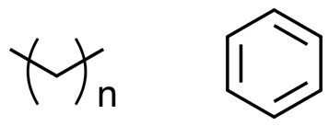

Discussion Questions:

- Why does persistence matter? Just because a molecule is persistent, it doesn’t necessarily mean it will be toxic to humans and the environment. Can you think of applications of chemicals where persistence would be an issue? Provide an example.

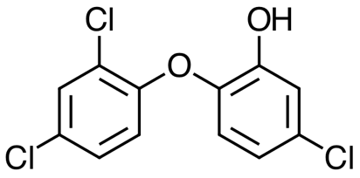
- Triclosan was used extensively as an antimicrobial agent in soaps, detergents and other household products. In 2016, the FDA announced that as of September 2017, they would prohibit the sale of consumer antiseptic washes containing triclosan. There are some health concerns linked to triclosan, including it being a possible endocrine disrupting chemical. Based on the structure, would you expect the chemical to persist in aerobic conditions?

- Research the structure of DDT, a pesticide used extensively in the 1950’s, and the “inspiration” to Rachel Carson’s Silent Spring (1962). The health effects are now well established for DDT. It is also widely known to be highly persistent. Identify the functional groups within the structure that make it highly persistent.

Organic Chemistry Concept: Alkanes, quaternary carbons; naming of alkanes; IUPAC nomenclature

Organic Chemistry Concept Map: 2.A.1.a. Bonding: In alkanes, carbons can be labeled as primary, secondary, tertiary, or quaternary depending on the number of non-hydrogen substituents (i.e., 1, 2, 3, or 4 respectively) on the labeled carbon.

Discussion:
Quaternary carbons have proven to be especially resistant to aerobic biodegradation. As a general rule of thumb biodegradation for substituted carbons follows the rule: primary > secondary > tertiary > quaternary, with the primary carbons being the most biodegradable under aerobic conditions.

Historic context:
Laundry detergents were developed in the early 1940s and widely replaced soap as the means for washing clothes. The 1950s brought about wide use of synthetic alkylbenzene sulfonate surfactants as the automatic washing machine became common in households. The most widely used surfactant was initially tetrapropylene alkylbenzene sulfonate (TPBS) – it was highly efficacious and easy to manufacture. The TPBS surfactant did not readily biodegrade and as a result sewage treatment plants had excessive foaming within their tanks, rivers with high concentrations of TPBS would see foaming water, and in some cases water would foam coming out of the tap.

A voluntary changeover from TPBS to a linear alkyl surfactant (linear alkylbenzenesulfonate (LAS)) was complete by early 1960s. There was tremendous public pressure to transition to the LAS, which is readily biodegradable in sewage treatment plants.

It was found that the excessive branching of the alkyl chains in the TPBS surfactant resulted in the high persistence and by simply changing alkyl chains to be linear the result was a surfactant that was much more readily biodegradable.

This example is likely the first example where structure was linked to performance or function of a chemical.
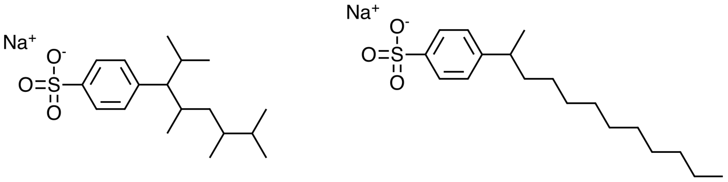
TPBS LAS

Vintage videos of detergent commercials showing excessive foaming and suds:
Dash: https://www.youtube.com/watch?v=F1YTHr4mTQA
Cheer: https://www.youtube.com/watch?v=lMxlAIeI8QI

Discussion questions:

- Name the alkyl chains on the TPBS and LAS structures above.

- Name the following alkanes. Identify the isomers.

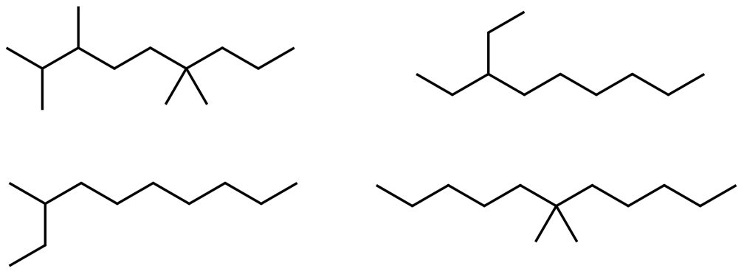

- Rank the alkanes in terms of their biodegradability (based on the design rules). Justify your ranking.

- Write condensed and bond-line formulas for three isomers of the alkane C₅H₁₂. Based on biodegradability design rules, rank the isomers in terms of biodegradability. Justify your ranking.

Organic Chemistry Concept: Electrophilic Aromatic Substitution, Substituent effects

Organic Chemistry Concept Map: 5.D.2.e. Chemical Reactions: Electrophilic aromatic substitution is a reaction between an electrophile and an aromatic compound (electron-rich component). The electrophile replaces hydrogen on the aromatic species. Electrophilic aromatic substitution reactions include bromination, nitration, sulfonation, Friedel–Crafts alkylation, and acylation.

Discussion questions:
Aerobic biodegradation of a phenyl ring typically proceeds by the electrophilic addition of oxygen to the phenyl ring. The oxygen reactive species can take on different forms, depending on the enzyme and conditions. Propose a simple mechanism for the electrophilic addition in which oxygen is introduced to phenol and compare it to chlorobenzene. Use a simple “E+” to represent the reactive oxygen species. Which do you believe will be more biodegradable under aerobic conditions and why?

Extension question: What do you believe would be the mechanism for electrophilic addition of oxygen to nitrobenzene. Would you expect nitrobenzene to be more or less biodegradable under aerobic conditions?
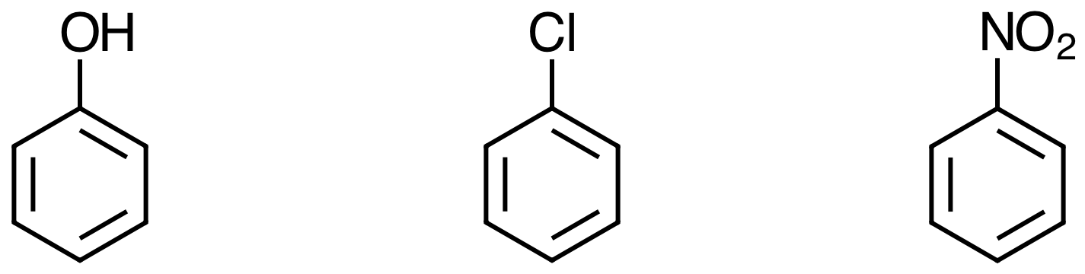

U.S. Food and Drug Administration. September 2, 2016, https://www.fda.gov/NewsEvents/Newsroom/PressAnnouncements/ucm517478.htm

