**Questions: Note to instructor: Below is a list of questions that are suitable for an exam. You may select any number of question that you may feel is best suited for your class. This serves a mere guide and any additional questions are welcome.**

**Questions for Exam 1**

1. **What is the Definition of Green Chemistry?**

“Green Chemistry is a revolutionary approach to the way that products are made; it is a science that aims to reduce or eliminate the use and/or generation of hazardous substances in the design phase of materials development”

1. **List 6 of the 12 Principles of Green Chemistry**

1. Waste Prevention

2. Atom Economy

3. Less Hazardous Chemical Synthesis.

4. Designing Safer Chemicals.

5. Safer Solvents and Auxiliaries.

6. Design for Energy Efficiency.

7. Use of Renewable Feedstocks.

8. Reduce Derivatives.

9. Catalysis.

10. Design for Degradation.

11. Real-time Analysis for Pollution Prevention.

12. Inherently Safer Chemistry for Accident Prevention

1. **What are the 3 Pillars of Green Chemistry?**

Economics, Cost, and Performance

1. **What happened in 1984 in Bhopal, India?**

A massive gas leak occurred at a Union Carbide plant where over 500,000 local residents were exposed to toxic methyl isocyanate gas! It’s considered to be one of the worst industrial disaster to date. Approximately 4,000 deaths occurred.

Decades later, residents are still impacted by the effects of the gas leak. Also the health of the residents has been compromised and the long term effects are yet to been reported.

1. **Fill in the blanks:**
2. **Risk = _Hazard__ + _Exposure____**
3. **How does Green Chemistry reduce Risk?**

Green Chemistry reduces risk by actively reducing the hazard through the 12 Principles.

1. **For companies who have won the Presidential Green Chemistry Awards, what were the benefits of implementing the 12 Principles of Green Chemistry?**

Instructor may reference a specific case study that he/she assigns the class to read. Refer to the PDF detailing the presidential Green Chemistry Awards to formulate your rubric.

Acceptable answers are:

* 1. Atom Economy
  2. Reducing Derivatization
  3. Inherent safer products
  4. Accident prevention
  5. And so on…..

1. **For companies that have implemented Green Chemistry into their research, how has Green Chemistry saved money? Applying certain Principles are acceptable.**

* Reduction in waste
* Decreased solvent use
* Less derivatization steps
* More benign solvents (i.e water)
* More energy efficient reactions
* Reduced reaction times = less labor costs

1. **You are an intern at a chemical company. Shortly after starting, you noticed that the research lab wasn’t very concerned with the hazards associated with the products they were making. You noticed that solvent usage wasn’t a concern, chemists were producing a lot of organic waste, and the lab had a noticeable chemical odor. What 12 principles apply and could help the lab? Explain?**

**Principles: 1,2,3,5,8,9,12**

Based upon students explanations, it’s up the faculty member to assess the merit of the response.

1. **What is matter? What is the fundamental unit of matter?**

Matter is defined as anything that occupies space and has a mass.

The fundamental unit of matter is……**The Atom**

1. **Which of the following represents an element and which of the follow represent a compound? Write answer below symbol**
2. **C b. He c. BaCl d. CF4**

Element Element Compound Compound

1. **Which of the following represents an element and which of the follow represent a compound? Write answer below symbol**
2. **CO2 b. Li c. CaCO3 d. FeO**

Compound Element Compound Compound

1. **Name the following elements:**
2. **Ti b. Ba c. Pb d. Ag**

Titanium Barium Lead Silver

1. **Write the symbol for each of the following elements:**
2. **Nitrogen b. Silver c. Mercury d. Argon**

N Ag Hg Ar

1. **What does the picture below represent? Label all appropriate**

Isotropic Symbol:

MN: Mass Number

AN: Atomic Number

E: Element

AN

E

MN

1. **What does the mass number represent?**

**Number of protons and neutrons in the atom**

1. **What does the atomic number represent?**

**Number of protons in the nucleus**

1. **What are the differences between: Proton? Electron? Neutron?**

**Proton – positive charge, resides in the nucleus**

**Electron – negative charge, resides outside of the nucleus**

**Neutron – no charge (neutral), resides in the nucleus**

1. **Where to Protons, Electrons, and Neutrons reside in the atom?**

**Protons and Neutrons reside at the center of the atom.**

**Electrons reside in the electron cloud.**

1. **A neutral atom with 9 protons will have how many electrons?**

**9 Electrons. Since it’s a neutral atom, the balance of the charge is zero.**

1. **What is the isotropic symbol of the element that has 44 protons in the nucleus of its atom.**

Ru

44

1. **What is the most abundant element on the earth?**

**Oxygen, O, is the most abundant element on the earth.**

1. **When an atom loses 2 electrons, the charge on its ion is? Is the new ion species a cation or anion?**

**Once an atoms loses 2 electrons the charge positively changes to 2. The new ion species would then be a cation.**

1. **An atom of an element has 2 electrons in the first valence shell, eight in the second valence shell, and 4 in the third shell. With this information, give the elements (a) name, (b) atomic number, (c) location on periodic table.**

**Name: Silicon**

**Atomic Number: 14**

**Location: Non-metal ( Group 4A, Period 3)**

1. **Indicate the trend of atomic radius and electronegativity across the periodic table. Use arrows to show increasing tendency across rows and columns for these parameters.**

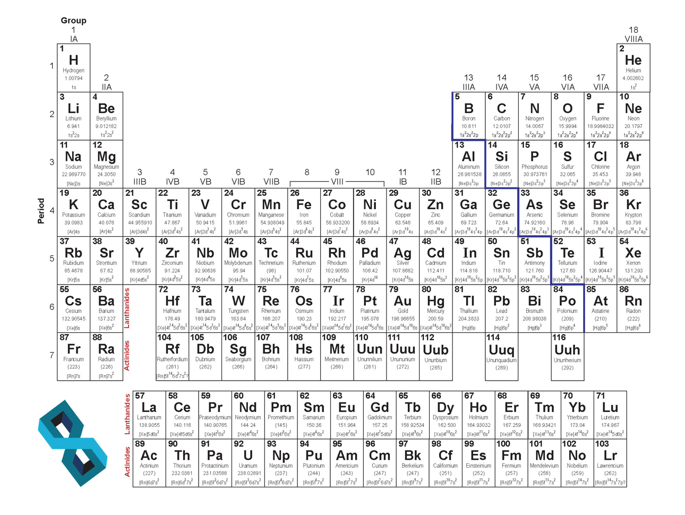

Atomic radius

Atomic radius



Electronegativity

Electronegativity

1. **How is a covalent bond different from an ionic bond?**

**A covalent bond is when to non-metals are held together through the sharing of electrons (via overlapping of orbitals). This results in an electronically neutral group of two or more atoms.**

**And Ionic bond is mainly different since its when a metal and non-metal are held together to form bonds.**

1. **Identify which compounds are covalently bonded and which ones have ionic bonds**

**Note to Instructor: Add your own structures**

1. **Using Lewis Dot Structures, show the sharing of electrons between a hydrogen atoms and a chlorine atom?**

Cl

H

**+**

Cl

H

**🡺**

1. **Draw the Lewis Dot Structure of Cl2. Label the bonding pairs and the lone pairs of electrons.**

Cl

Cl

1. **Draw the Lewis Dot Structure of methane and ethane. Label the bonding pairs and lone pairs of electrons.**

H

H

H

H

H

H

H

C

C

C

H

H

H

1. **Provide the correct nomenclature for the following compounds (common names are acceptable):**





 2,3-Dimethyl-1-hexene 6-Methyl-2-heptanol. 1-Chloro-3-methylcyclohexane

Benzene 1-Bromo-3-ethylcyclopentane 2,4-Heptadiene

1. **Draw the correct structures for the following names:**
2. **2,4-Dimethylheptane**
3. **2-Methyl-4-octene**
4. **1-Chloro-2-methylcyclopentane**







1. **Draw the correct structures for the following names:**
2. **Phenol**
3. **6-Methylheptanol**
4. **1-Methylcyclobutane**
5. **3-ethyl-2,4-dimethylhexane**
6. **3-ethyl-2-methylheptane**
7. **1-bromo-2-fluorocyclohexane**
8. **Cyclobutane**





1. **What is Biomimicry?**

Biomimicry is the approach to innovative novel materials and solutions for a more sustainable future by emulating nature and its intrinsic chemistry, systems and patterns.

1. **Name one type of way Green Chemistry is changing the way chemical reactions are performed.**

Refer to the 12 Principles of Green Chemistry. Ensure student directly correlates answers to any of the principles and explain their choice with an example.

1. **Why does Green Chemistry look at nature for future reactions? What does nature do that is hard to perform in the lab?**

Green Chemistry looks to nature since nature tends to be the most efficient at performing a wide range of chemical transformation at the fraction of the time. Furthermore, nature does everything at room temperature and with the highest selectivity and minimal waste.

1. **Name the following functional groups**



**Carboxylic acid nitrile ketone**

1. **Atorvastatin is a “statin” lowering drug what has a range of functional groups. Identify all the functional groups in the compound Atorvastatin.**

Amide

Alcohol

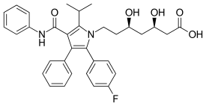

Carboxylic acid

Amine

Halogen

1. **Here is the structure of specialty compound that can be used in reversible reactions to block the amino acid residues in proteins. What functional groups are associated with this compound? (This one is tricky)**

Alkene



Acid Anhydride

1. **How many atoms are present in one mole (12g) of atomic carbon? Show all work for full points.**

**6.022 x 10^23 atoms**

1. **Answer the question for the reaction below:**

**KMnO4 + H2C2O4 + HCl 🡺 MnCl2 + CO2 + KCl + H2O**

1. Balance the equation (7 pts)

**2 KMnO4 + 5 H2C2O4 + 6 HCl 🡺 2 MnCl2 + 10 CO2 + 2 KCl + 8 H2O**

1. For a complete reaction of 1.5 mol of KMnO4, how many moles of H2C2O4 are needed (2 pts)?

3.75 moles

1. When 0.45 mol of CO2 are produced from the reaction, how many GRAMS of H2O are also produced (2 pts)?

6.48 grams of H20

1. How many moles of MnCl2 can be produced by the reaction of 5.0 mol of KMnO4 3 mol of H2C2O4 and 22 mol of HCl (2 pts)?
2. **The following reaction is the Diels-Alder reaction. Answer all question thoroughly to get maximum points.**



1. Write out the names of each molecule in this reaction

1,3-butene 1-triene 4-methylcyclohexene

1. If 400 g of the product was generated, how much total reagents are utilized if a yield of 82% is achieved?

Note: The diels-alder reaction is a 1:1 stiochiometric rection and a highly atom economical reaction.

Theoretical yield = 487.8g

400g of total reagents were utilized.

1. What is the atom economy of this reaction?

Theoretically, the atom economy is zero!!