Activity
- Use “Yes, and…” momentum

- Mind map your ideas and design a product

- Create an advertisement poster for your product
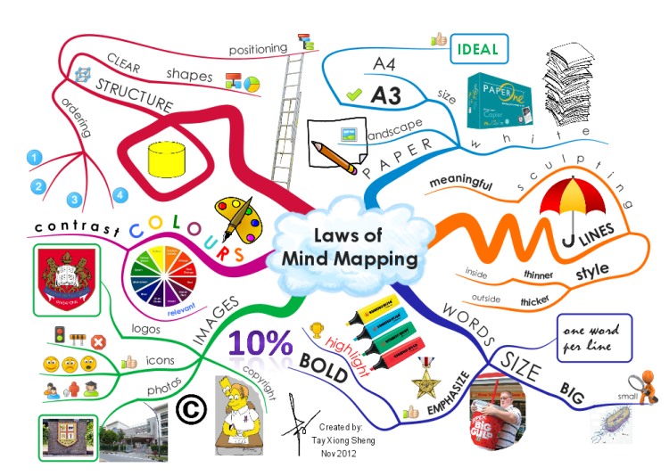http://www.biggerplate.com/mapImages/xl/0d45a123-9ba0-4053-820b-689f69fc9b6a.png

Team Design

Use biomimicry to innovate a product which addresses food, water, and/or energy issues

Worksheet

- What is your problem you are trying to solve?

- What is your solution? What is the name of your solution?

- How has your solution been inspired by nature?

- How does your solution address food, water, and/or energy challenges?

