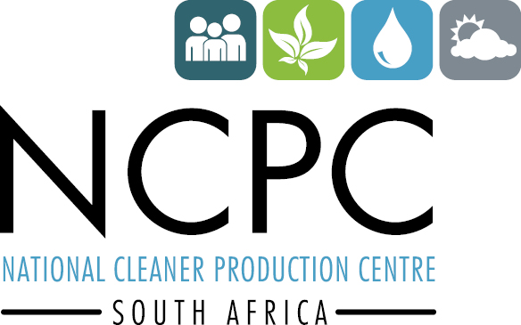

GREEN CHEMISTRY
Train the Facilitator Workshop
CSIR, Knowledge Commons, Meiring Naude Road, Brummeria, Pretoria.

PROGRAMME
DAY 1
08:00-08:30 | Registration
08:30 - 09:00 | Welcome  Wynand van der Merwe, Skills Development Manager: NCPC-SA  Khaled El Mekwad, UNIDO Representative and Head of the South Africa Regional Office: UNIDO  Karolina Mellor, Center for Green Chemistry & Green Engineering at Yale
09:00 – 10:30 | Morning Session I: Sustainability 1  - Sustainability – Myths and Facts  - Society, Economy, and the Environment
10:30 - 10:45 | Tea/ Health Break
10:45 - 12:15 | Morning Session II: Sustainability 2  - Business and Sustainability  - Applying Green Chemistry to Management  - Different Models of Sustainability  - Case Study: The Interface Company  - In-Class Discussion
12:15 – 13:15 | Lunch
13:15 – 14:45 | Afternoon Session I: Sustainability 3  - Describe Processes for Reporting and Measuring Sustainable Actions  - Life Cycle Assessment  - Definitions & Examples  - In-Class Exercise
14:45 -15:00 | Tea / Health Break
15:00 – 16:30 | Afternoon Session II: Disasters and Unintended Consequences  - Chemical and Industrial Accidents  - Union Carbide, 1984  - Cuyahoga River, 1969  - Port of Tianjin, 2015  - Unintended Consequences  - Green Chemistry is Everybody’s Job  - Perspective and Context  - Green Chemistry – Where do we go from here?
16:30 | Break for the day
DAY 2
09:00 – 10:30 | Morning Session I: Definitions & Benefits of Green Chemistry  - What is Green Chemistry  - Twelve Principles  - Chemical and Green Chemistry Design  - The Market and Demand for Green Chemistry  - Examples of the Twelve Principles
10:30 - 10:45 | Tea/ Health Break
10:45 - 12:15 | Morning Session II: Metrics  - Why do we need Metrics in Green Chemistry?  - Established Metrics in Green Chemistry  - Atom Economy  - Environmental (E) Factor  - Atom Utilization  - Reaction Mass Efficiency  - Additional Metrics used in Green Chemistry  - Process Mass Intensity  - Life Cycle Assessment  - Ecological Indicator/Ecological Footprint  - In Class Discussion
12:15 – 13:15 | Lunch
13:15 – 14:45 | Afternoon Session I: Renewable Feedstocks for Energy  - Petrochemistry 101  - First, Second, and Third Generation Feedstocks  - The Advantages and Drawbacks of Biofuel
14:45 -15:00 | Tea / Health Break
15:00 – 16:30 | Afternoon Session II: Renewable Feedstocks for Molecules  - Renewable Feedstocks  - Biomass Feedstocks  - Carbohydrate Feedstocks  - Lipid Oils and Terpenes as Feestocks  - Protein Feedstocks  - Renewable Feedstocks as a Source of Molecules  - A Little History of Vanillin  - Platform Molecules and Bio Privileged Molecules
16:30 | Break for the day
DAY 3
09:00 – 10:30 | Morning Session I: Catalysis  - Activation Energy for Reaction  - What is a Catalyst?  - Types of Catalysts  - Catalysts and Sustainability  - Important Improvements Using Catalysts  - Enzymatic Reactions  - Examples and Considerations
10:30 - 10:45 | Tea/ Health Break
10:45 - 12:15 | Morning Session II: Solvents  - What are solvents and how are they used?  - Conventional Solvents  - Alternative Solvents  - Solvent Selection  - In-Class Exercise  - Solvent Replacement
12:15 – 13:15 | Lunch
13:15 – 14:45 | Afternoon Session I: Energy Delivery in Chemistry  - Role of Energy in a Chemical Process  - Microwaves  - Flow Chemistry  - Photochemistry  - Electrochemistry
14:45 -15:00 | Tea / Health Break
15:00 – 16:30 | Afternoon Session II: Metrics  - The Waste Treatment Pyramid  - Reduced Solvent Use  - Waste as a Feedstock  - Biodegradation of Waste  - Designing Processes to Include Biodegradation of Waste  - In-Class exercise
16:30 | Break for the day
DAY 4
09:00 – 10:30 | Morning Session I: Designing for Reduced Hazard 1  - Hazard and Risk – Past and Present  - Toxicology  - In-Class Discussion  - Assessing Hazards and Exposure  - What Happens When You’re Exposed?
10:30 - 10:45 | Tea/ Health Break
10:45 - 12:15 | Morning Session II: Designing for Reduced Hazard 2  - In-Class Exercise  - Hazard Minimisation Through Molecular Design  - QSAR-Quantitative Structure Activity Relationship  - Molecular Design Research Network (MoDRN)
12:15 – 13:15 | Lunch
13:15 – 14:45 | Afternoon Session I: From Theory to Practice  - Implementation: Why, What, and How  - Understanding Context  - Green Chemistry in the Marketplace  - Identify Opportunities  - Life Cycle and Green Chemistry Principles as a Guide to Finding Opportunity  - Delivering Innovation  - Green Chemistry Strategies at All Stages  - Green Chemistry Assessment Tool  - How to Proceed: Moving Forward
14:45 -15:00 | Tea / Health Break
15:00 – 16:30 | Afternoon Session II: Innovation  - Transformative Innovation  - What is it that we really want?  - Nature as Inspiration  - Design Challenges  - Biomimicry  - Colour  - Adhesives  - Self-Cleaning  - There is Still More We Can Learn from Nature
16:30 | Break for the day

DAY 5
09:00 – 09:20 | Importance of Green Chemistry in South Africa (dti)
09:20 – 09:50 | South African baseline study (Faith)
09:50 – 10:15 | Presentation of South African Case Study (1) (Dean Brady)
10:15 - 10:30 | Tea/ Health Break
10:30 – 11:00 | Presentation of South African Case Study (2) (Dean Brady)
11:00 – 11:20 | Presentation of Green Chemistry in Kenya ()
11:20 – 11:40 | Presentation of Green Chemistry in Uganda ()
11:40 – 12:00 | Research performed by the Chemical Industries SETA (CHIETA) on skills management with regards to Industry 4.0 and Greening of operations
12:00 – 13:00 | LUNCH
13:00 – 13:30 | Next steps in Green Chemistry Project (Tanya)
13:00 – 14:30 | Question and Answer/Discussion
14:30 | Close Out

FACILITATORS PROFILE:

Professor Audrey Moores

Audrey Moores is an Associate Professor of Chemistry and Tier II Canada Research Chair in Green Chemistry (2007-17) at McGill University. She is a leading expert in the field of catalysis using metal, metal oxide and biomass-based nanomaterials, with a special emphasis on sustainable processes and use of earth abundant starting materials. Her research was recently highlighted in Nature in 2016, and she was selected as an emerging leader in 2017 by the RSC journal Green Chemistry.

Career
She is the scientific director in the board of GreenCenter Canada, an Ontario-based tech transfer company, and the associate director of the Facility for Electron Microscopy Research (FEMR) at McGill since 2017. She is a member of the advisory board of the Green Chemistry Institute (America Chemical Society) since 2018. Since 2016, she is an associate editorship for ACS Sustainable Chemistry & Engineering.
She received a Discovery Accelerator Supplement Award in 2018 from the Natural Sciences and Engineering Research Council of Canada. She was recently invited by the United Nations Industrial Development Organization for to teach a 5-day workshop in South Africa in the fall 2018.
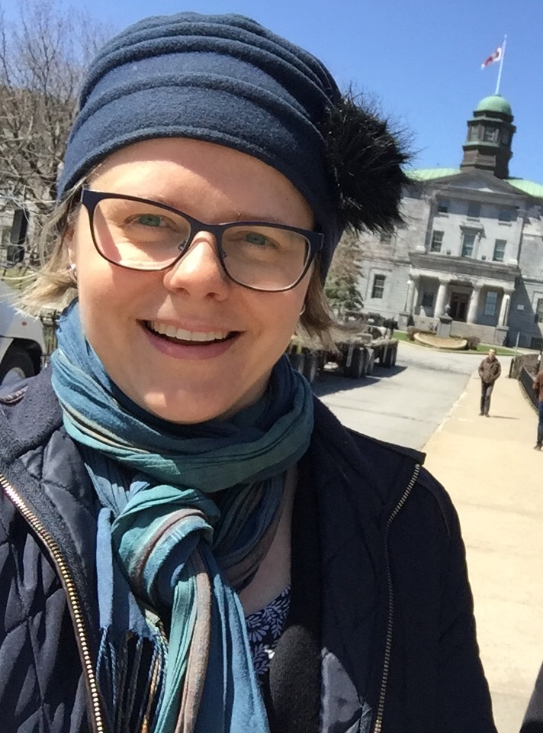

Dr Karolina Mellor

Karolina Meloor in a Program Manager, Education Lead, Center for Green Chemistry & Green Engineering at Yale University with experience in green chemistry education and research. She joined the Center 5 years ago and coordinated multiple projects, including Global Green Chemistry Initiative.

Karolina has many roles in the Center for Green Chemistry & Green Engineering including operations, outreach and development, but her primary role is to lead educational efforts in green chemistry. She translates research into teaching tools to educate diverse audiences in green chemistry and sustainability. Her expertise includes online/traditional teaching and instructional design, educational games development and workshop design.

Before coming to Yale, Karolina received her Ph.D. in molecular biology from the University of Virginia. She also worked at the University Innovation Licensing and Ventures Group where she evaluated patent strategies and explored commercial potential of technologies developed at the university.

